Compiling C programs with GLUT on Windows 10

# Download and install: FreeGLUT libraries compatible with Visual Studio.

1. First download the FreeGLUT libraries for Visual Studio from the following website:

<http://www.transmissionzero.co.uk/software/freeglut-devel/>

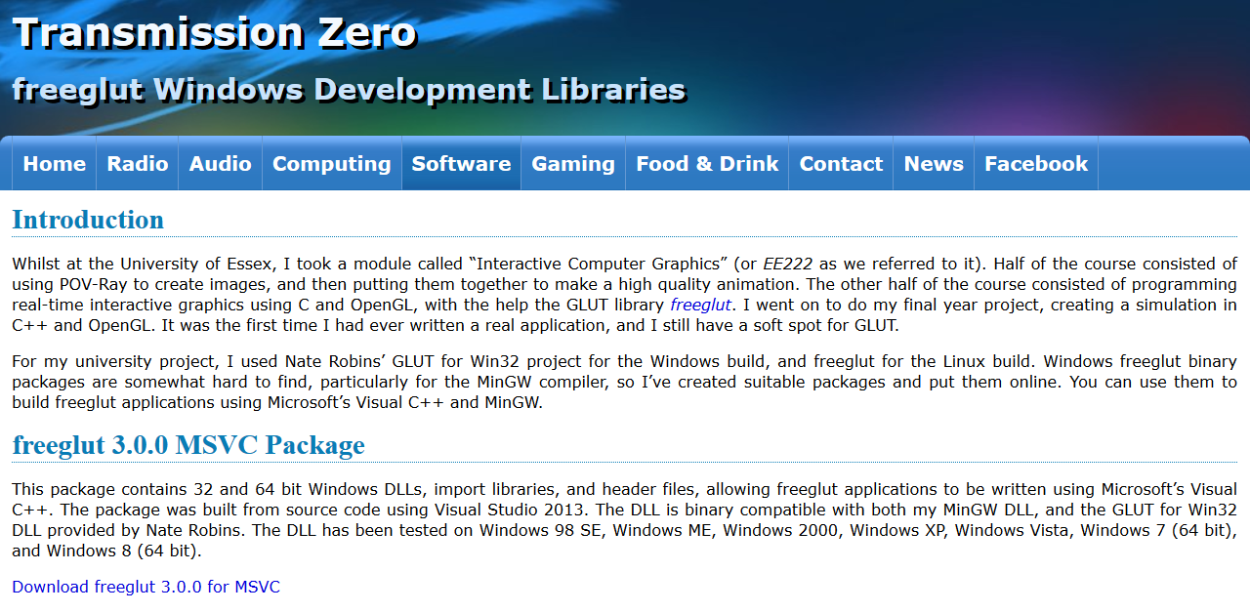

2. Click the link for freeglut 3.0.0 MSVC Package located at:

<http://files.transmissionzero.co.uk/software/development/GLUT/freeglut-MSVC.zip>



3. You will be prompted to save freeglut-MVSC-3.0.0-2.mp.zip on your local hard drive. On my computer, this file was saved to the Downloads folder.

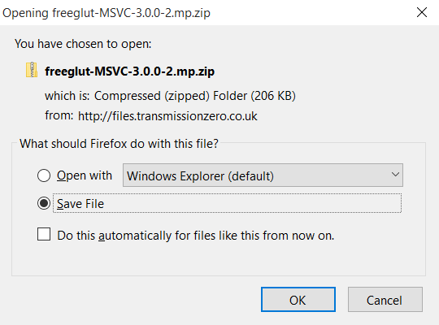

4. Once the file is finished downloading, please go to the Downloads folder. On my computer the location is C:\Users\rob\Downloads. You should see the following file in that folder:

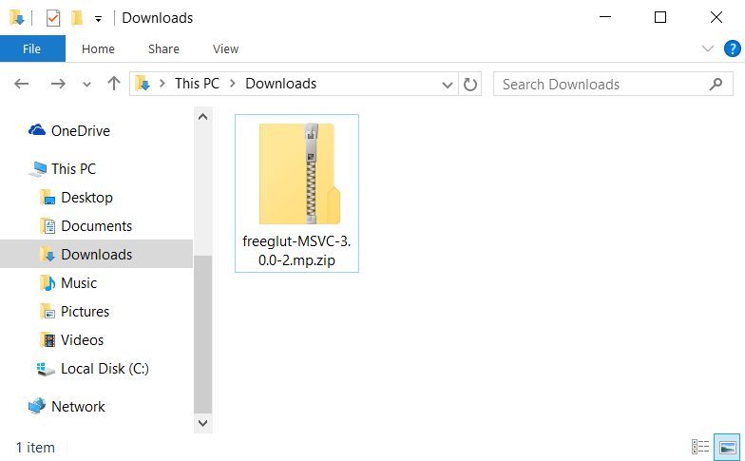

5. Unzip (uncompress) this archive. I did this by clicking the right mouse button once while the mouse cursor was hovering over the file icon for freeglut-MSVC-3.0.0-2.mp.zip:

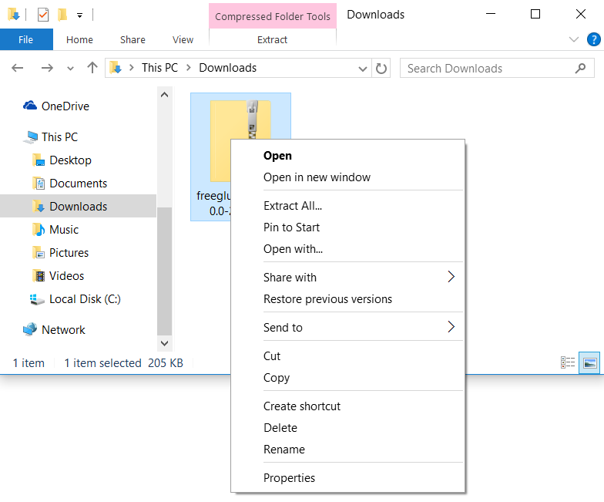

6. Click option **Extract All...**



7. You will be prompted to enter the location to save the uncompressed file. I chose the current location (Downloads).

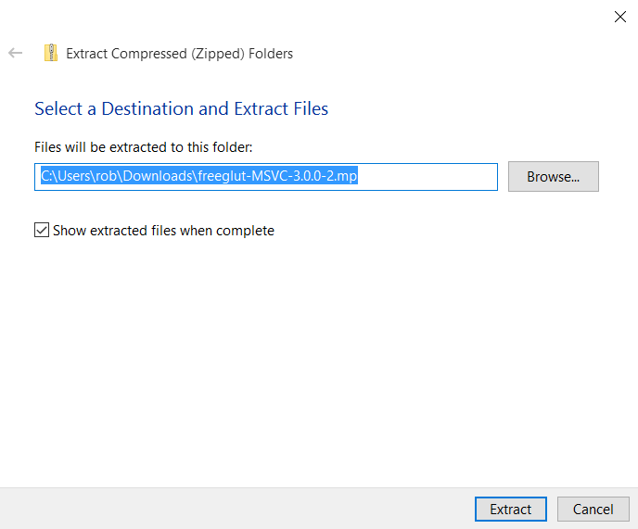

8. Now I have an uncompressed version of the freeglut folder.

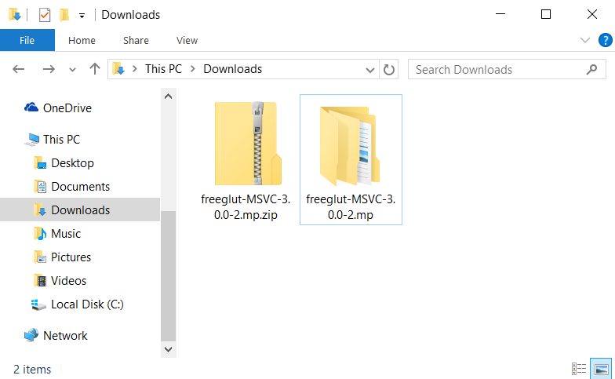

9. Next step is to move the uncompressed freeglut folder to a new location. I put my copy in my home directory (C:\Users\rob). To move this archive, I’ll use cut-and-paste. After positioning my mouse over the freeglut folder, I click my right button. A menu should pop-up.

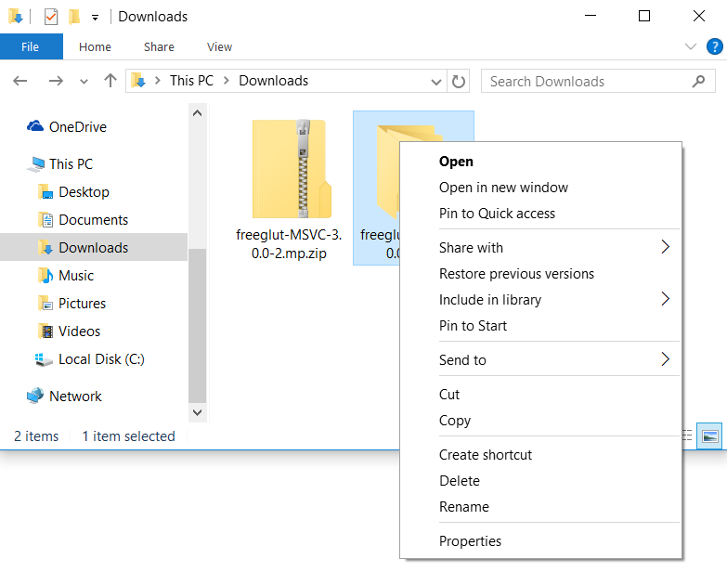

10. Select **Cut**.



11. The folder will appear transparent to indicate it has been cut.

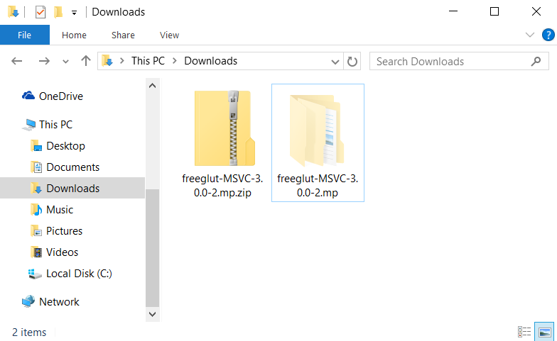

12. I will then navigate to C:\Users directory and highlight my home directory (rob).

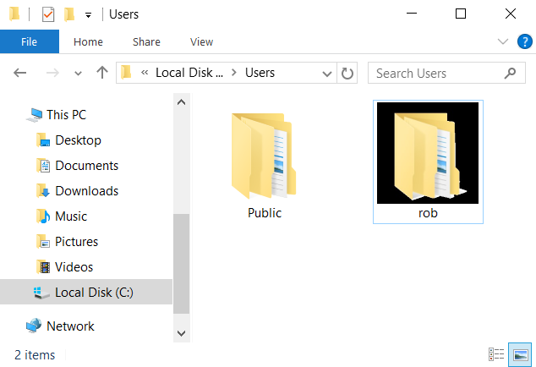

13. With mouse cursor hovering over rob folder, I click my right mouse button. A popup menu appears. Click **paste**.

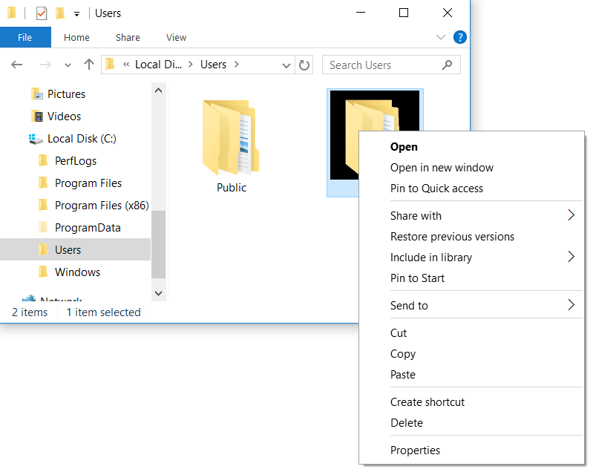

14. I have now successfully moved my freeglut library to its new location: **C:\Users\rob\freeglut-MSVC-3.0.0-2.mp**

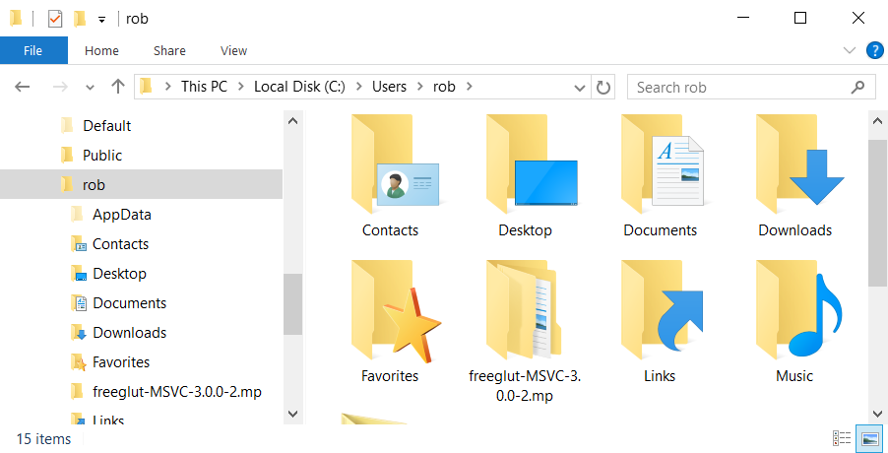

# Download and install: Visual Studio Express.

1. Visual Studio Express is a free download from Microsoft. First go to the following web address:

<https://www.visualstudio.com/en-us/products/visual-studio-express-vs.aspx>

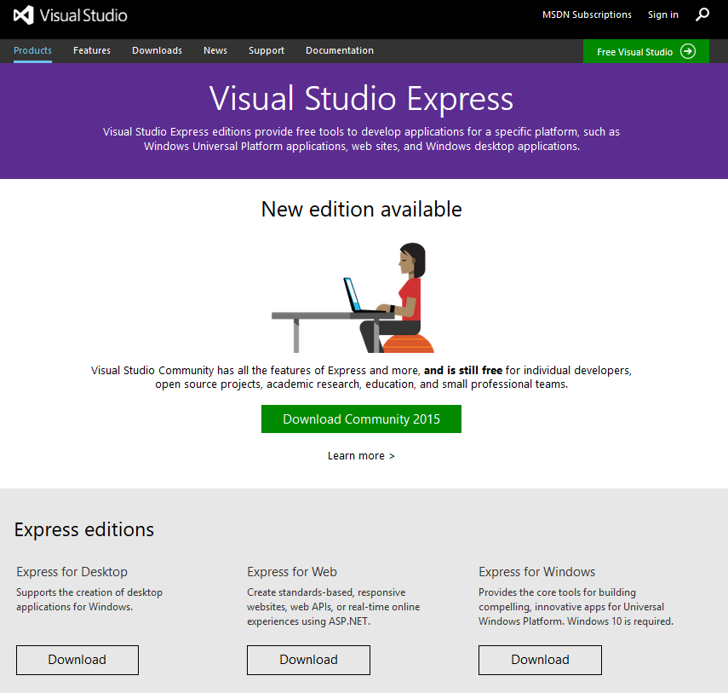

2. Click the **Download** button associated with “Express for Desktop”.



3. A pop-up window will appear prompting you to save the file. Click the **Save File** button. The file will most likely save to your Downloads folder. On my computer this file is saved in C:\Users\rob\Downloads.

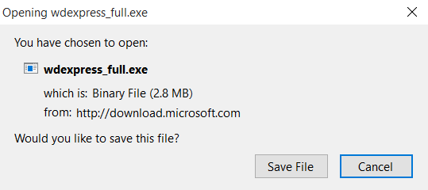

4. Go to your Downloads folder. There should be a file there titled “wdexpress_full.exe” In this example, I’m navigating to C:\Users\rob\Downloads. Click on this program to install it.

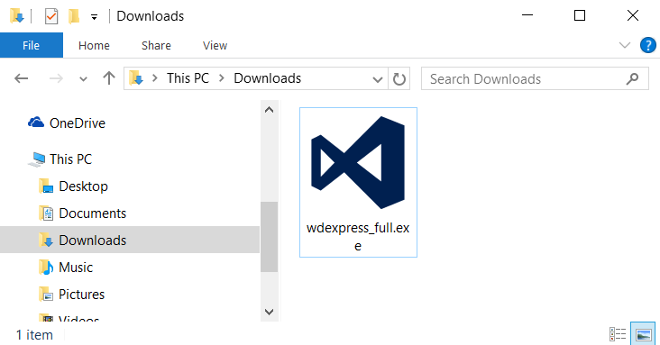

5. An install screen for Visual Studio will appear like the screenshot below. Use the default settings for installation location. Press the **Install** button.

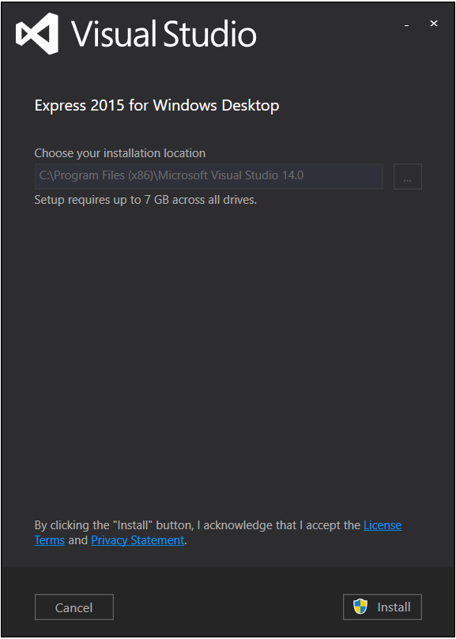

5. A confirmation pop-up window will appear. Click the **Yes** button.

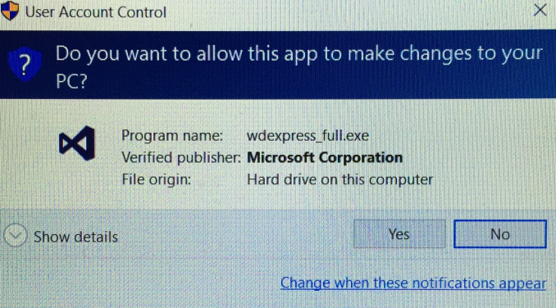

6. Installation may take a while. Once Visual Studio Express is installed, you should see the following screen. Click the **LAUNCH** button.

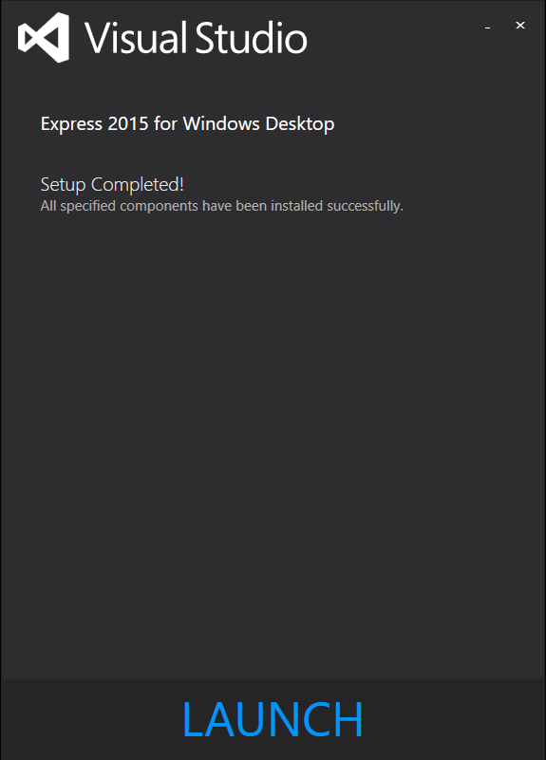

# Configuring Visual Studio Express with FreeGLUT.

1. Visual Studio should now be running. Select **File**.A drop-down menu will then appear.

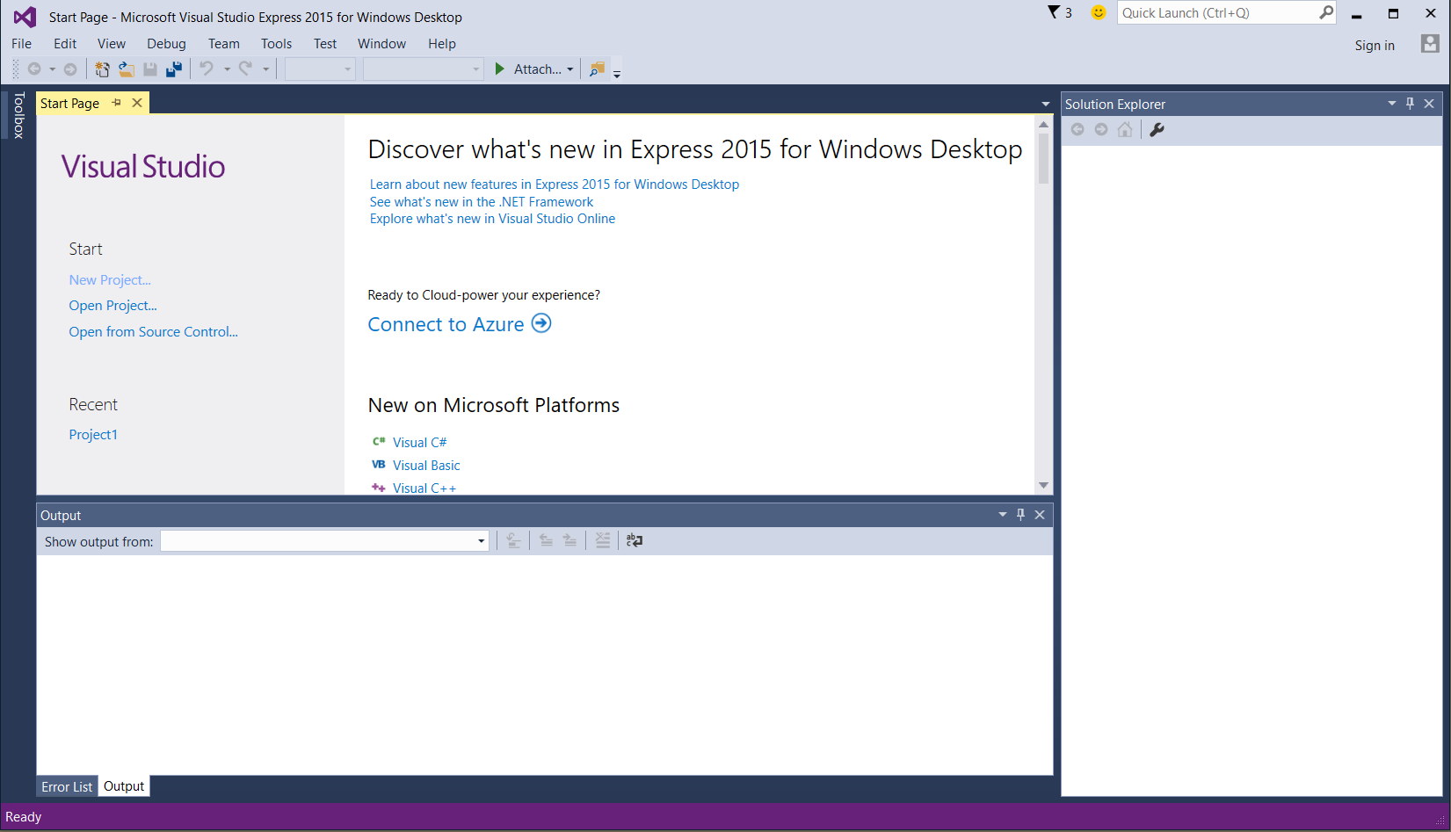

2. Select **New Project…**

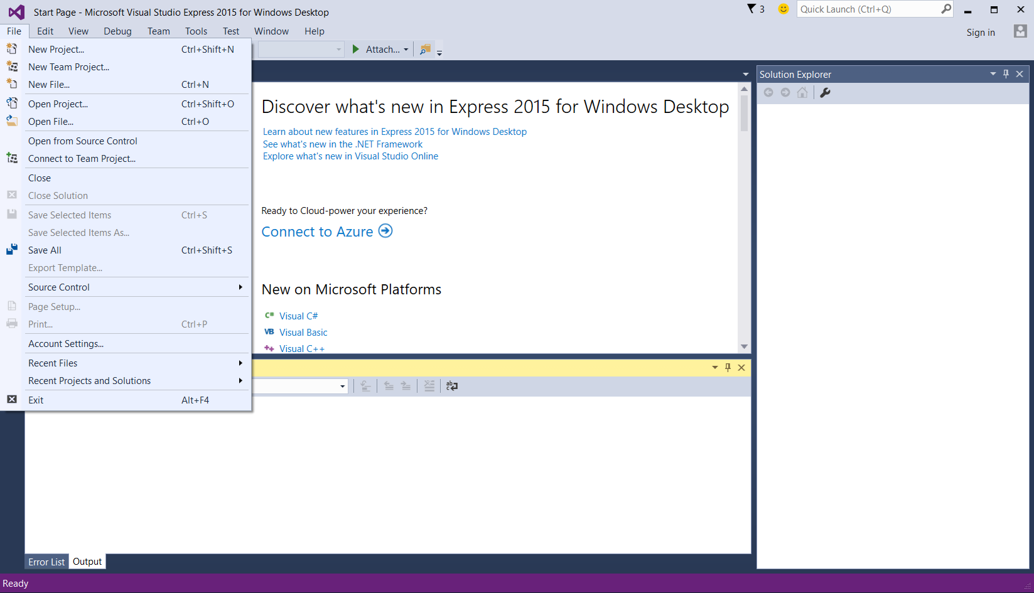

3. Select **Empty Project**

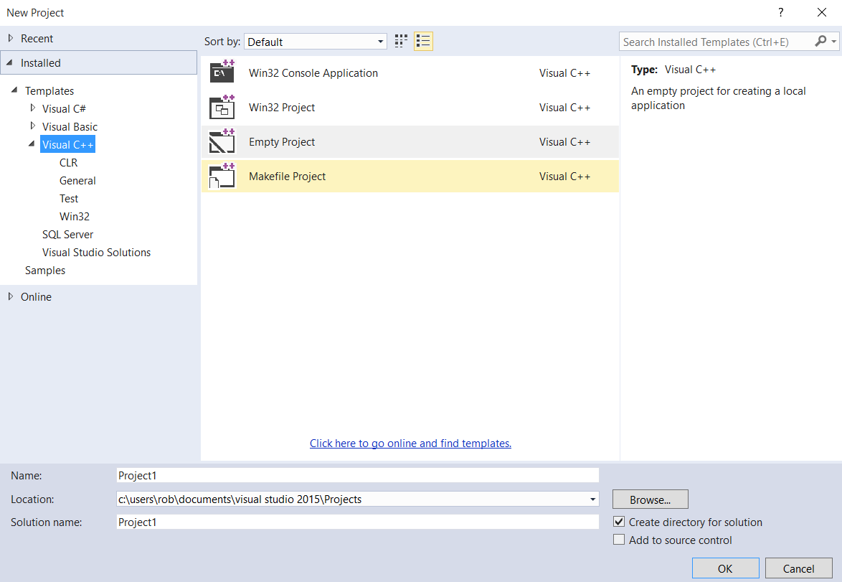

4. For name of the project, use **Project1**.

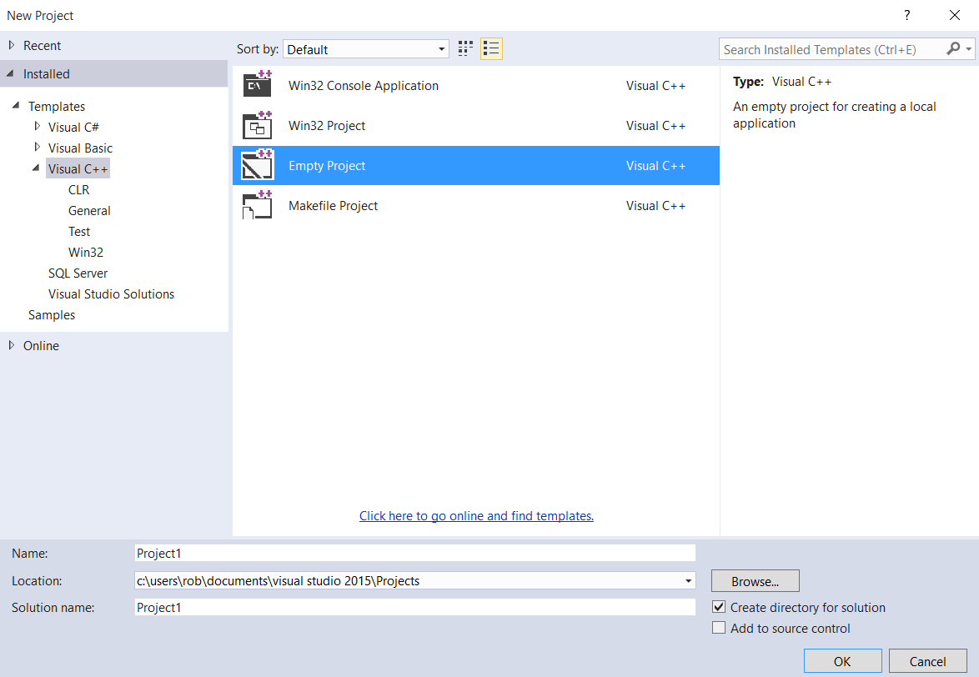

5. For location, use the default location. In my case, this project will be saved in **C:\users\rob\documents\visual studio 2015\Projects**



6. For solution name, use **Project1**



7. Make sure there is a checkmark in the box next to **Create directory for solution**



8. Click the **OK** button.



9. The next step is to associate a C (or C++) program with Project1. I will use the following example program available on our CS-116A Canvas website:

Windows-triangle_square_circle_hexagon.c

Note: when I downloaded my copy of this C program from Canvas, I saved it to the following location:

C:\Users\rob\Documents\Visual Studio 2015\Projects\Project1\

This is the location where Visual Studio Express stores my project files. For simplicity, I want to keep my project files and source code in one location.

Click **File**

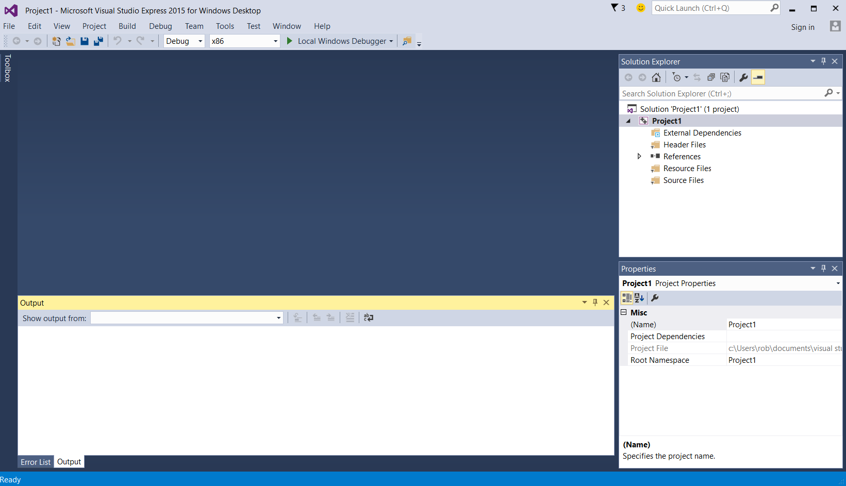

10. Select **Open File…**

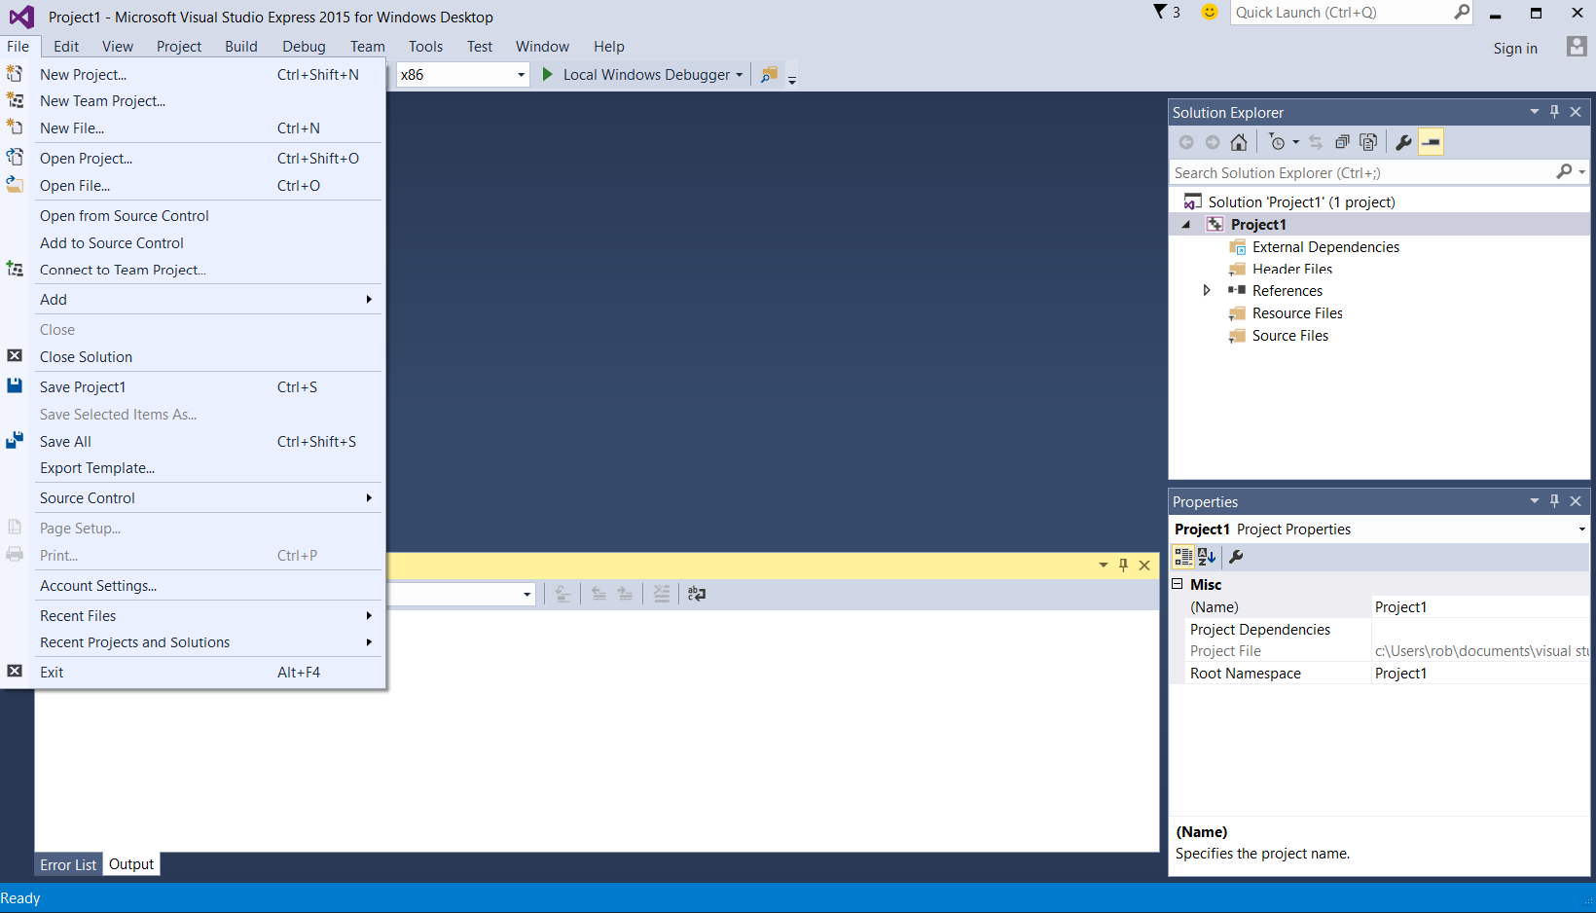

11. Select **Windows-triangle_square_circle_hexagon.c**

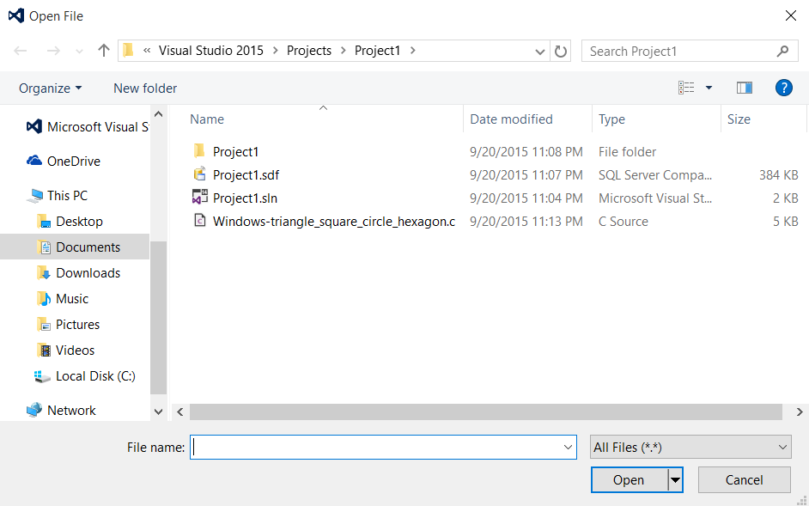

12. Press **Open** button.

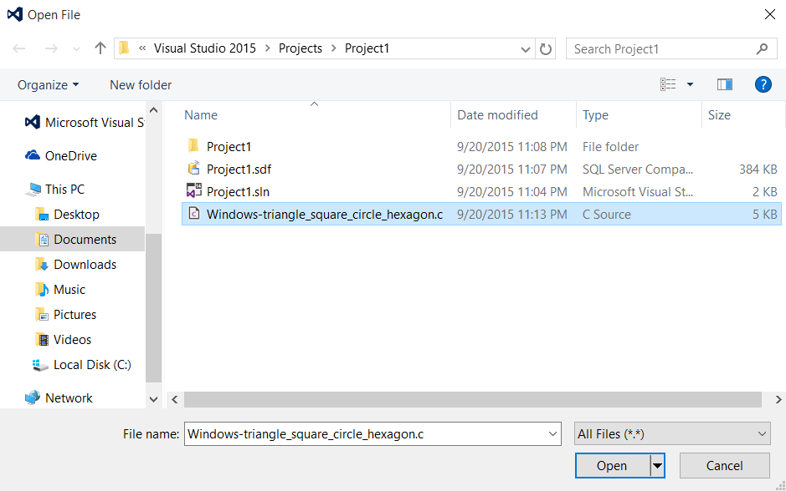

13. Select **File→Move Windows-triangle_square_circle_hexagon.c into**

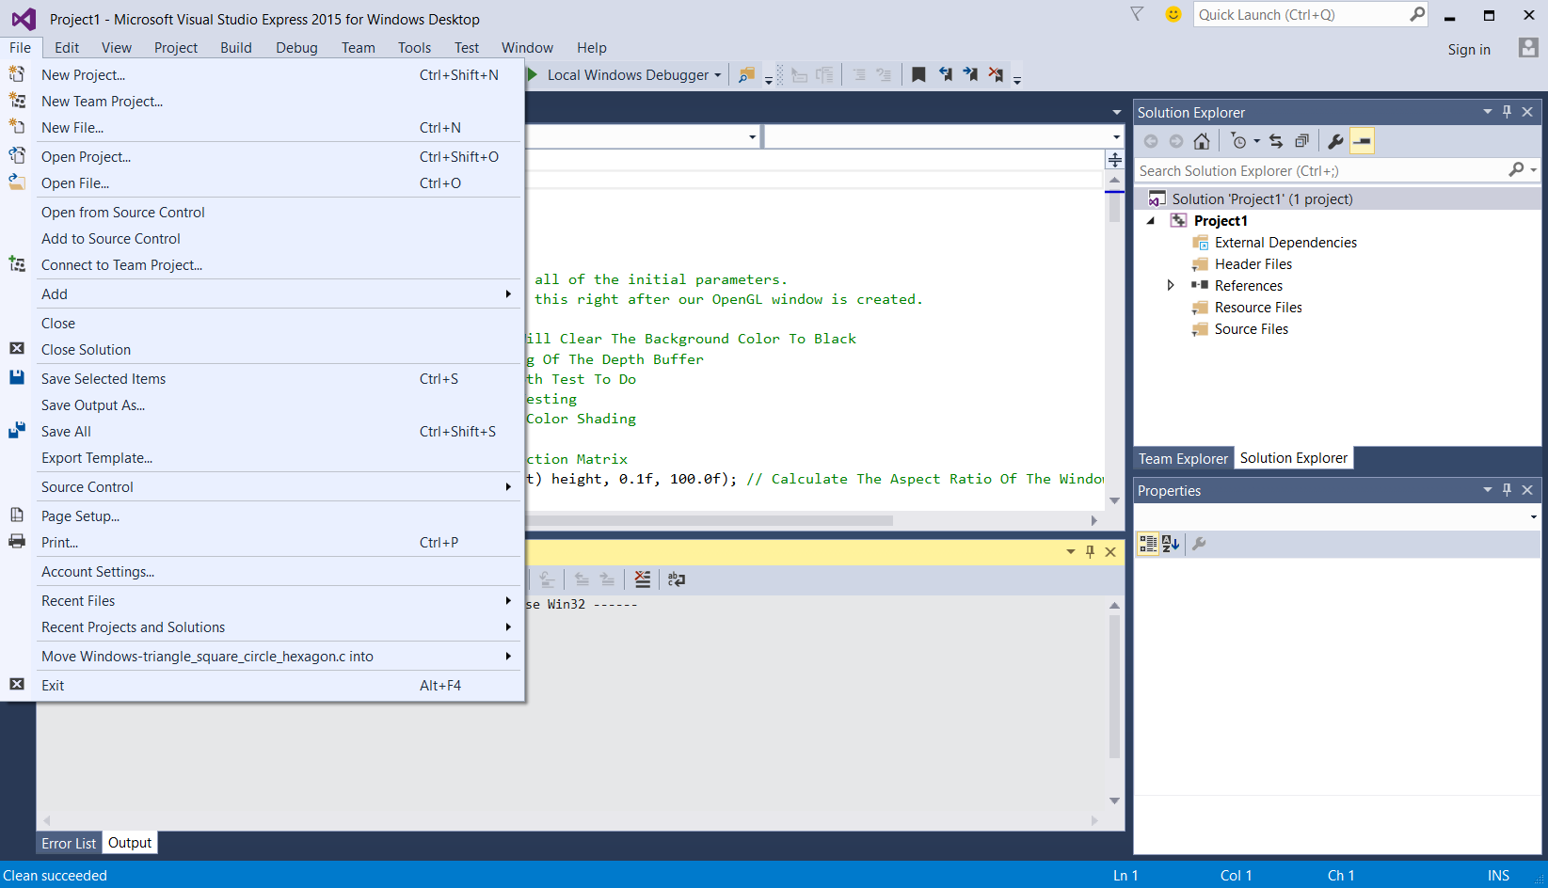

14. Select **Project1**

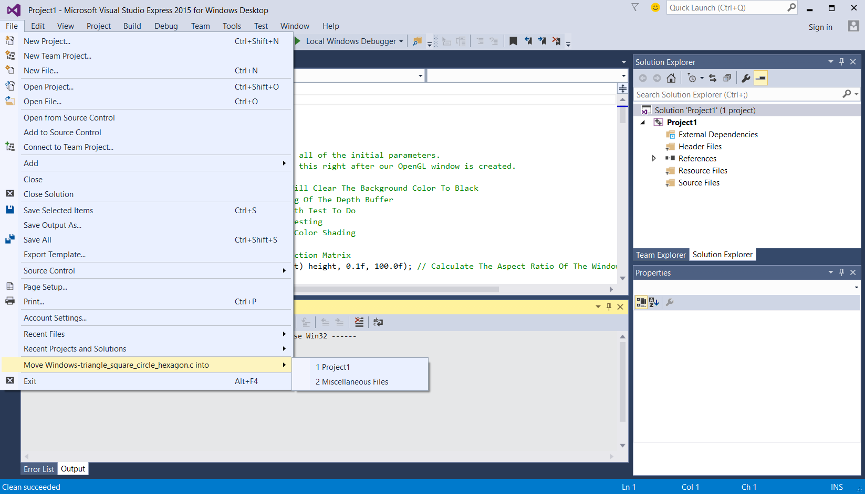

15. We have successfully created Project1. The next step is to configure the header files path in Visual Studio Express. We want to add the location of our freeglut directory’s header files into Visual Studio Express. Select **Project** from the menu.

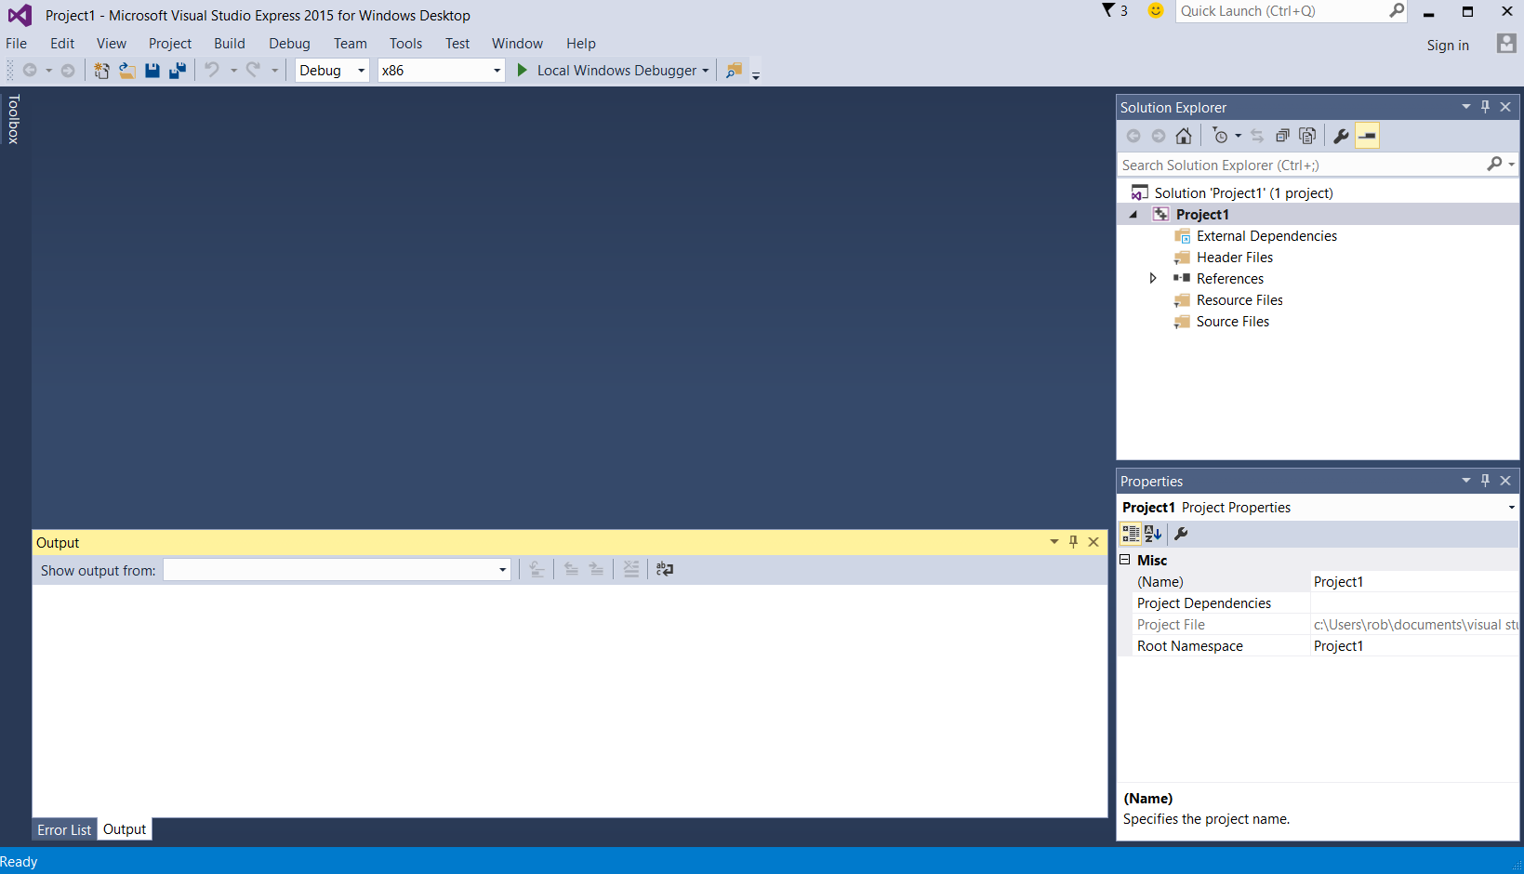

16. Select **Properties**

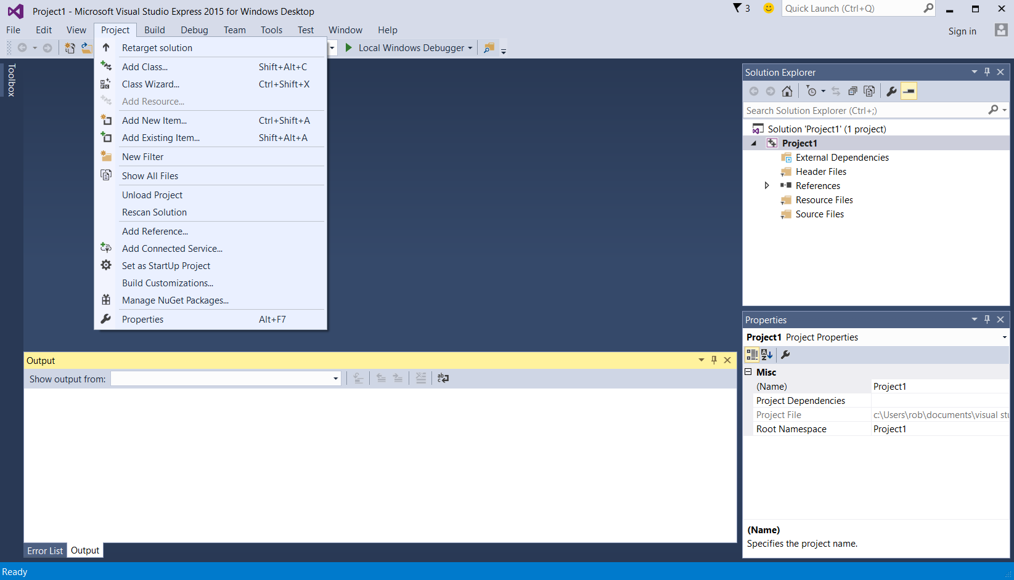

17. A new properties window will appear. Select **VC++ Directories**

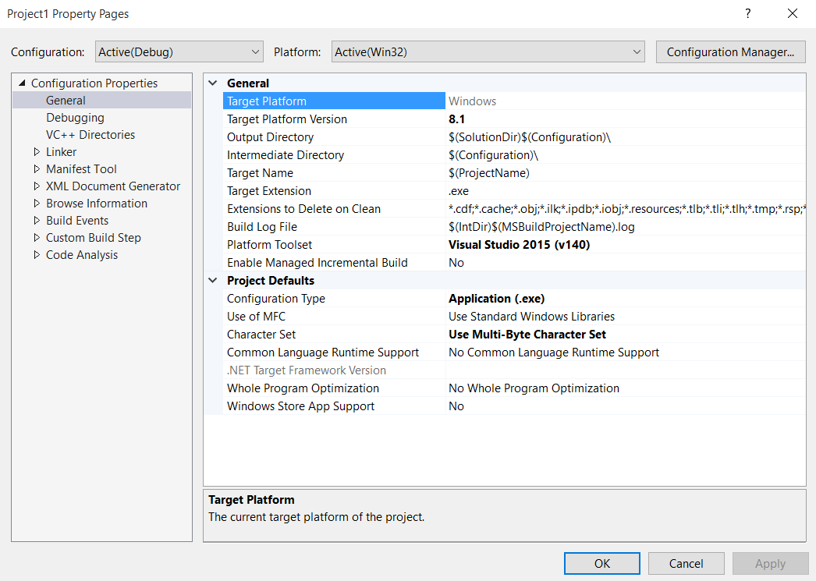

18. Select **Include Directories**

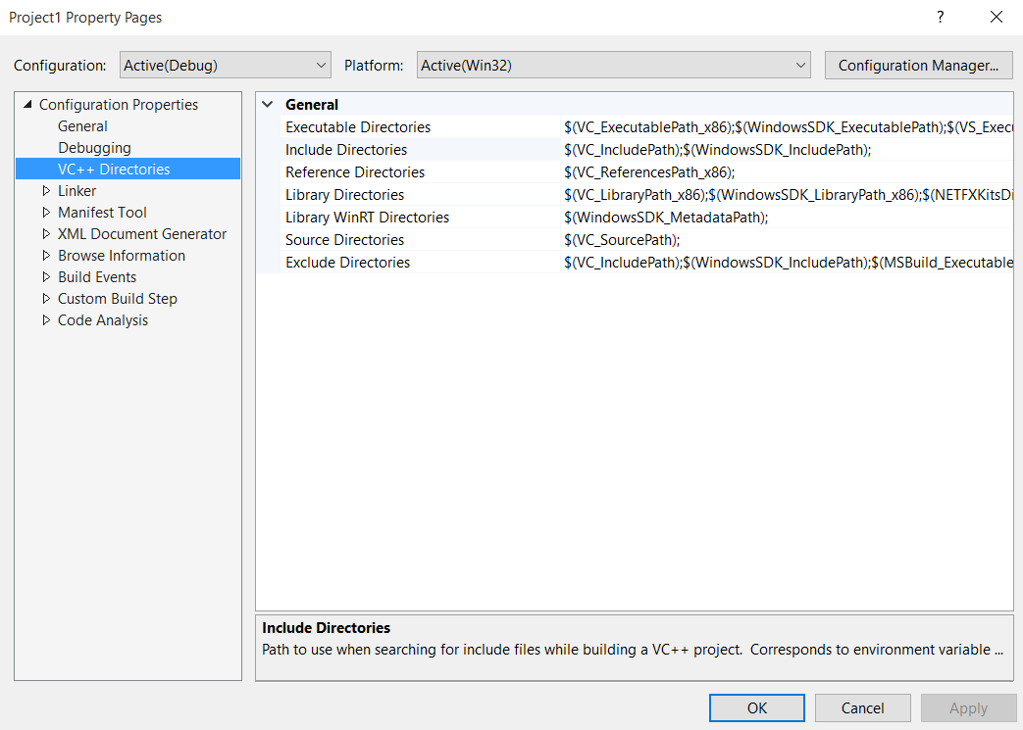

19. Click the gray down arrow button to expand the list of include directories.

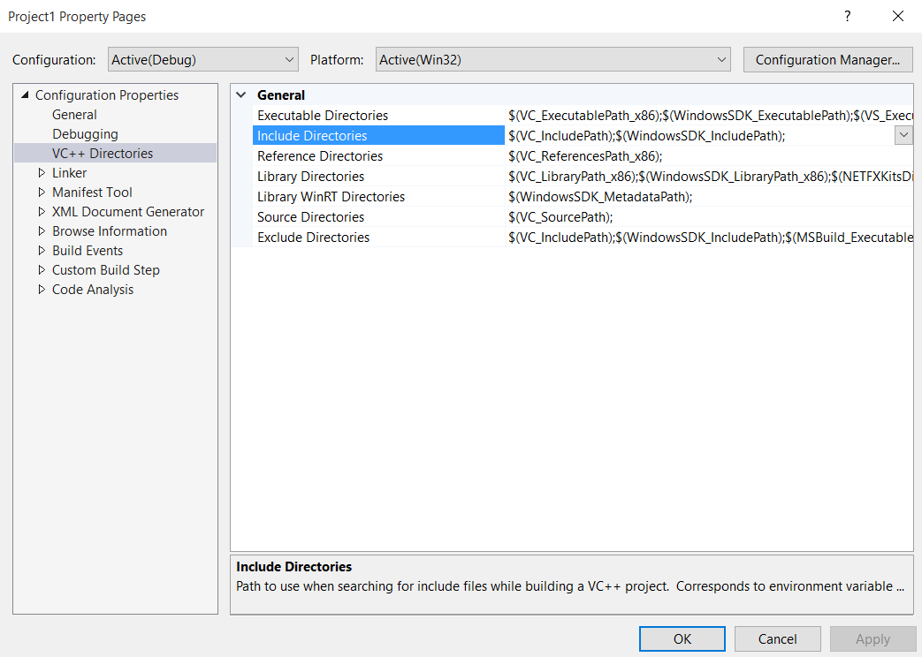

20. Click **<Edit…>**

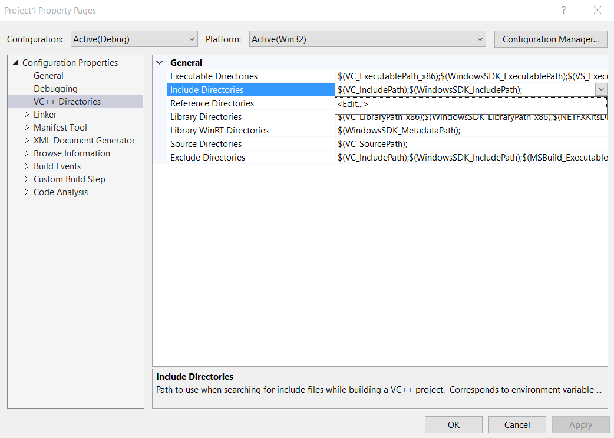

21. A new pop-up window will appear. We can now add custom library include paths for Project1. Doing so means we won’t have to specify an absolute path to the GLUT header files we’ll be using in our C/C++ programs. Early in this document, I downloaded and installed the freeglut library to the following location: C:\Users\rob\freeglut-MSVC-3.0.0-2.mp. The freeglut library has an include subdirectory. We will add that subdirectory to Visual Studio. Click on the **folder** icon.

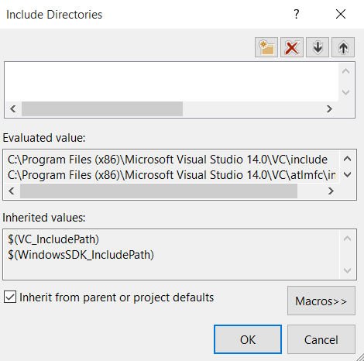

22. Click the “**…**” (dot dot dot) button.

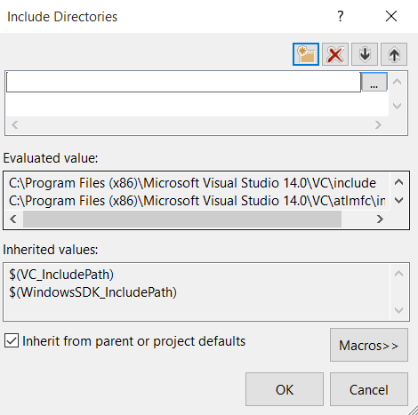

23. A new file-browsing window will pop up. Next we’ll navigate to where the freeglut library is installed: C:\Users\rob\freeglut-MSVC-3.0.0-2.mp. Click on **Local Disk (C:)**

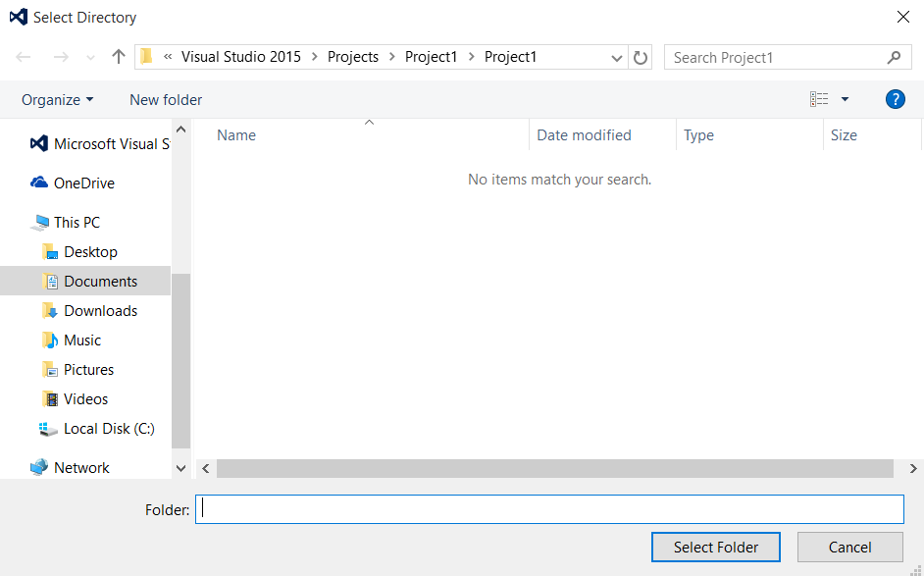

24. Click **Users**

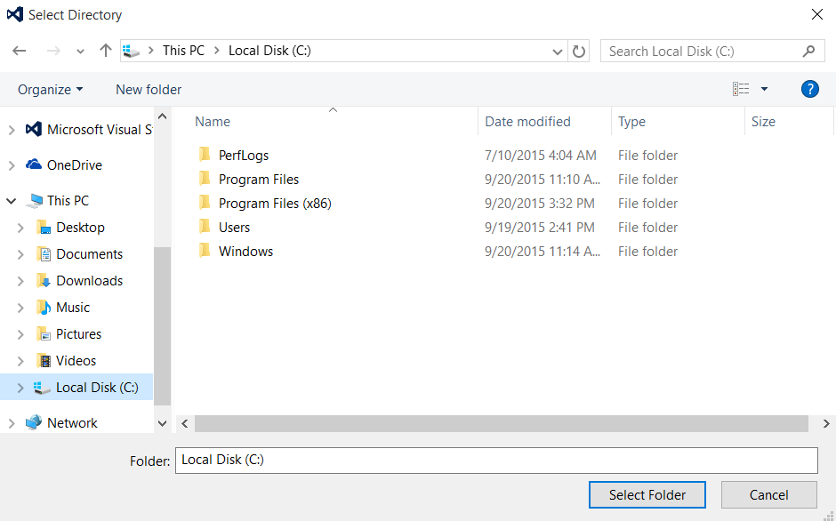

25. I click the **rob** folder because that’s where my home directory is located. You will probably have a different home directory name.

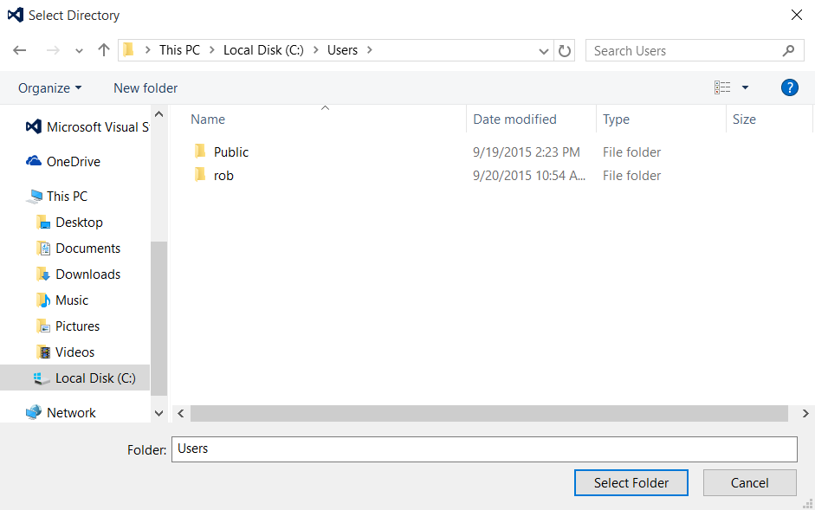

26. Now click on the **freeglut-MSVC-3.0.0-2.mp** folder. As I noted in earlier instructions, this is where I installed freeglut.

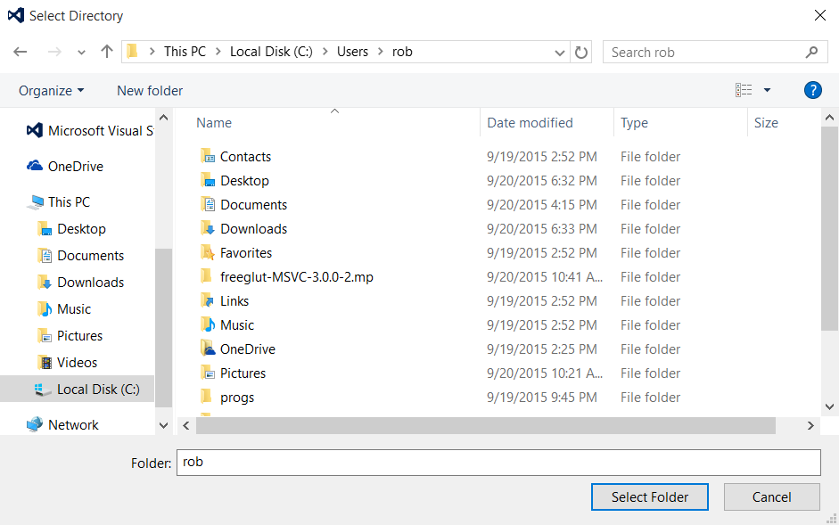

27. Now click on the **freeglut** folder.

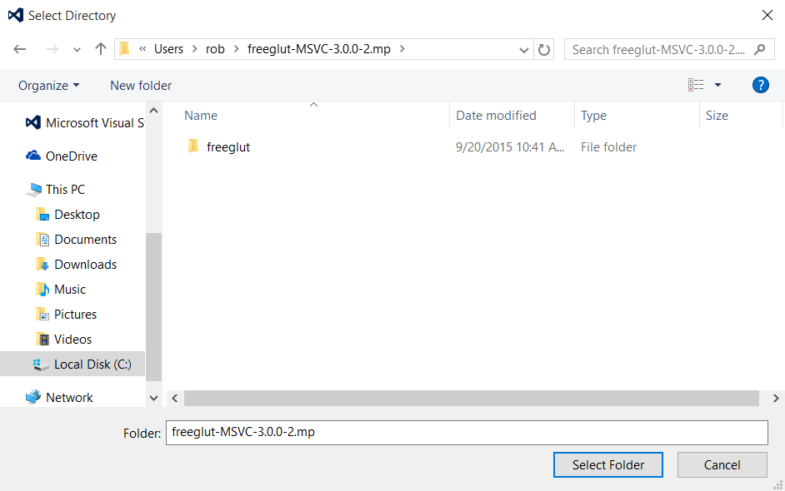

28. Now click on the **include** folder.

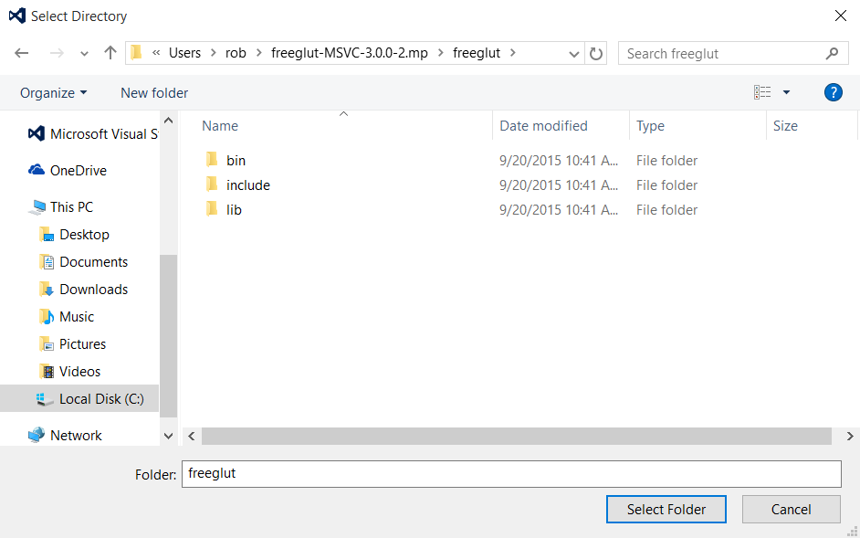

29. Now click on the **GL** folder.

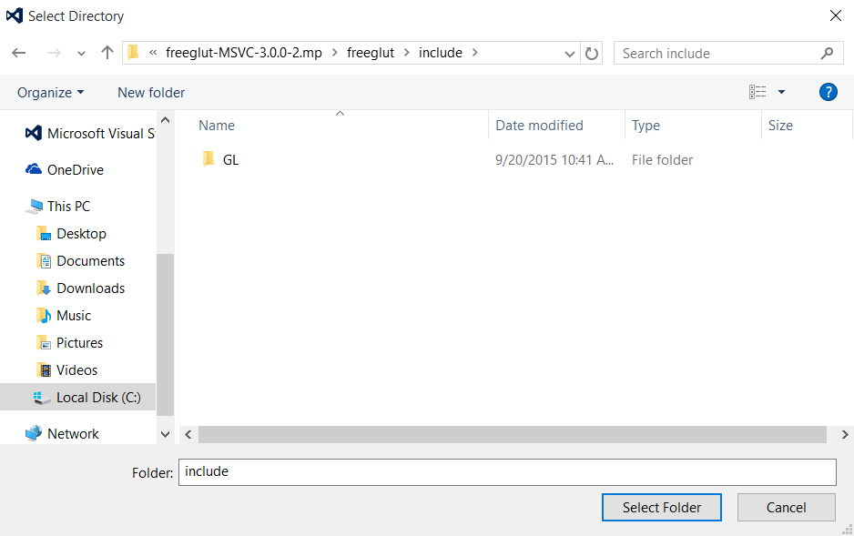

30. The file-browsing window will be replaced with the following window (see screenshot below). I’ve now added C:\Users\rob\freeglut-MSVC-3.0.0-2.mp\freeglut\include\GL to my include path for project1. Click the **OK** button.

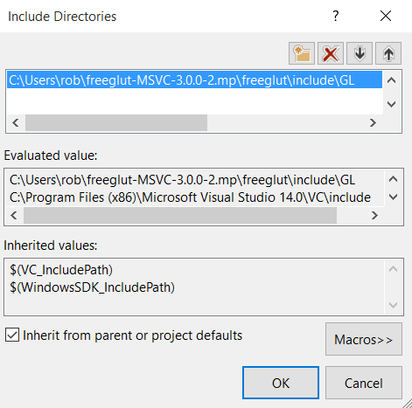

31. Visual Studio Express has now been configured with the freeglut includes library path for project1. The next step is to configure Visual Studio Express with the binary freeglut libraries. Select **Library Directories**

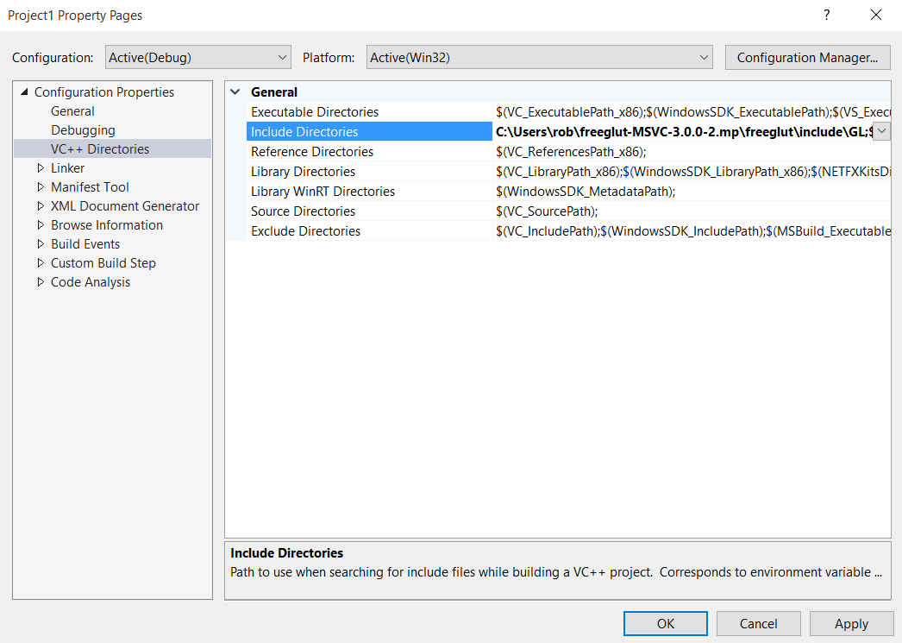

32. Click the grey **down arrow** button.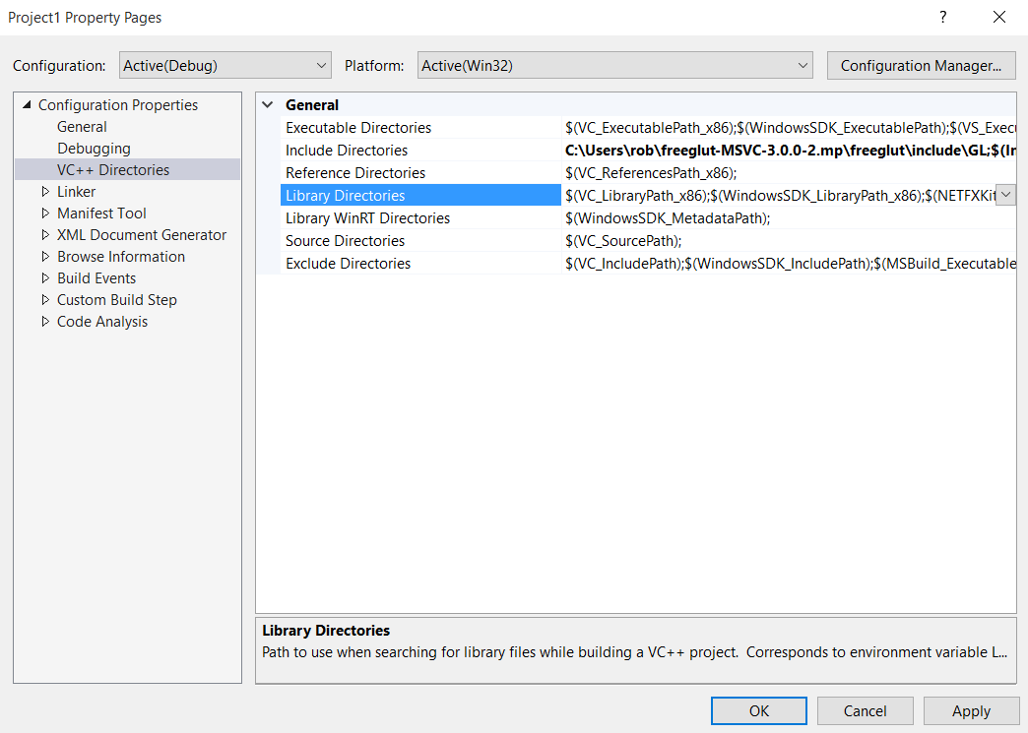

33. Click **<Edit…>**

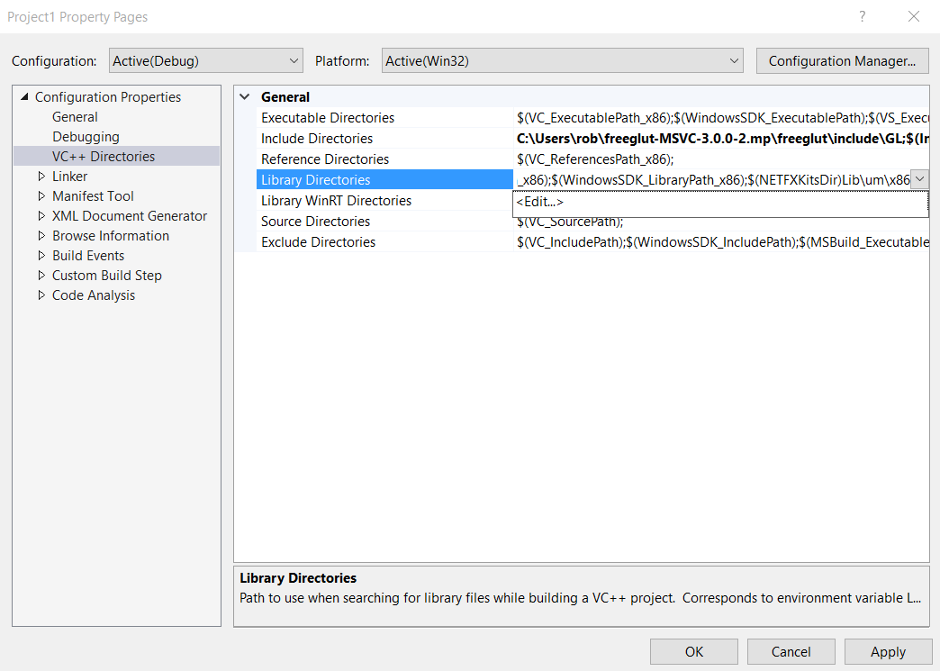

34. A new window will pop up. Click the **folder** button.

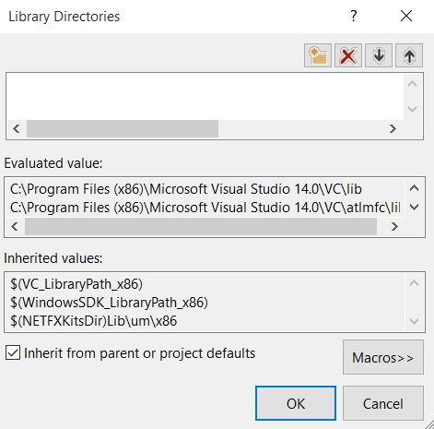

35. Click the “**…**”(dot dot dot)button.

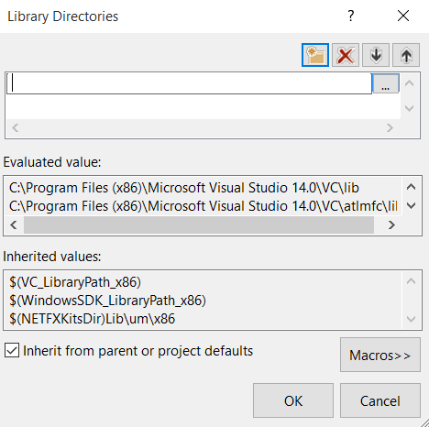

36. A new file-browsing window will appear. Select **Local Disk (C:)**

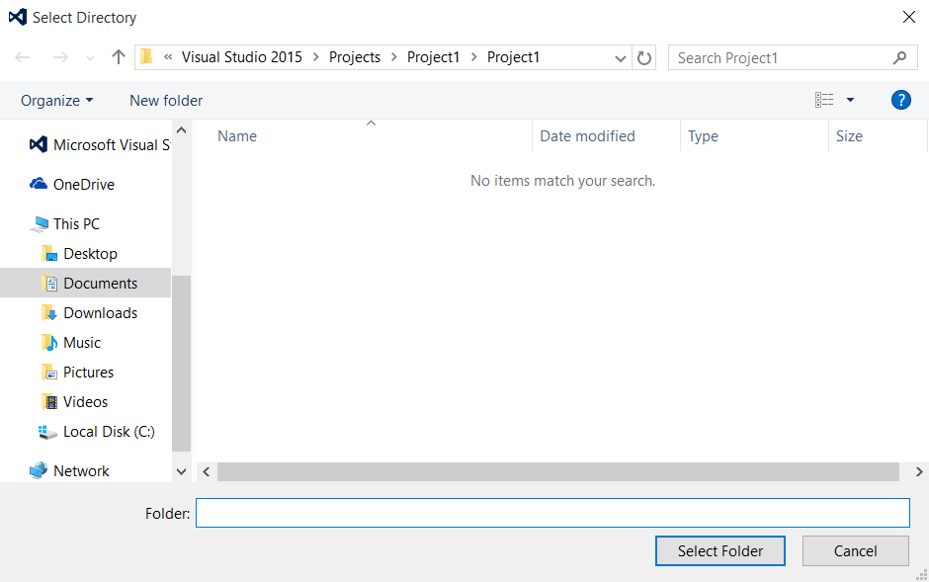

37. Select **Users** folder.

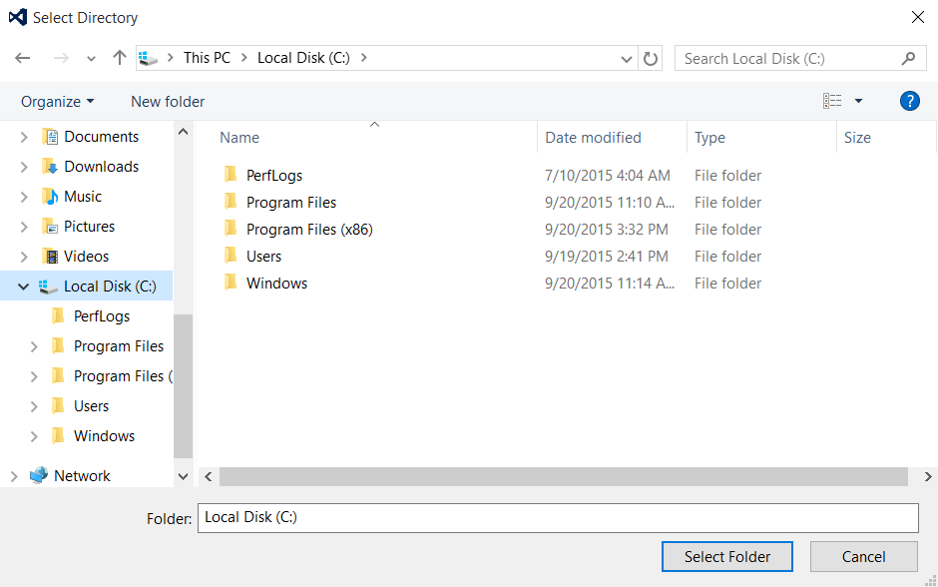

38. On my system, I needed to select **rob** folder because that’s where my home directory is located. You may have a different name for your home directory.

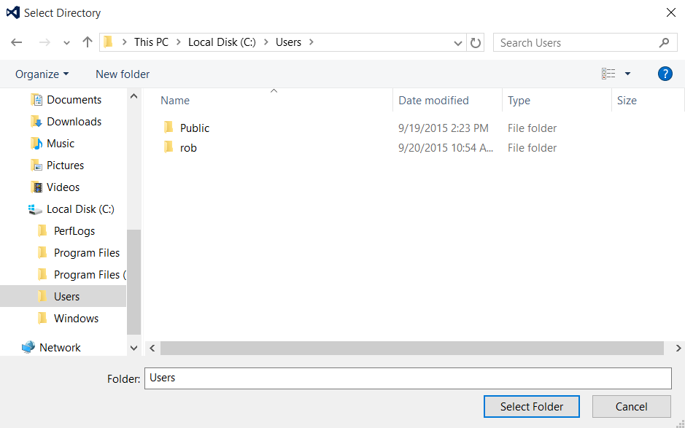

39. Select **freeglut-MSVC-3.0.0-2.mp** folder.

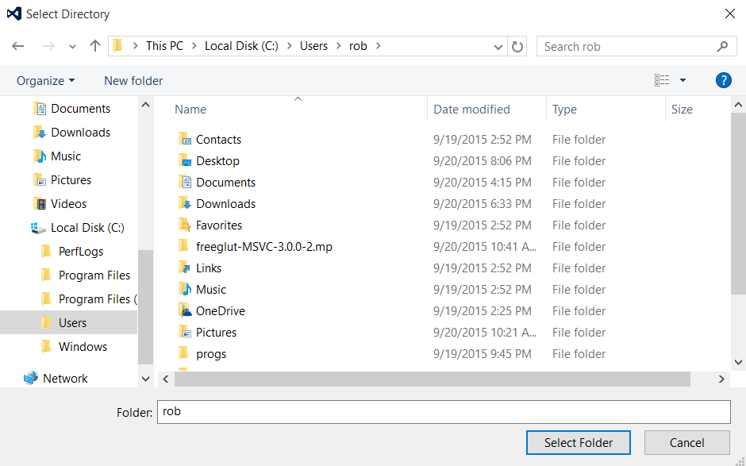

40. Select **freeglut** folder.

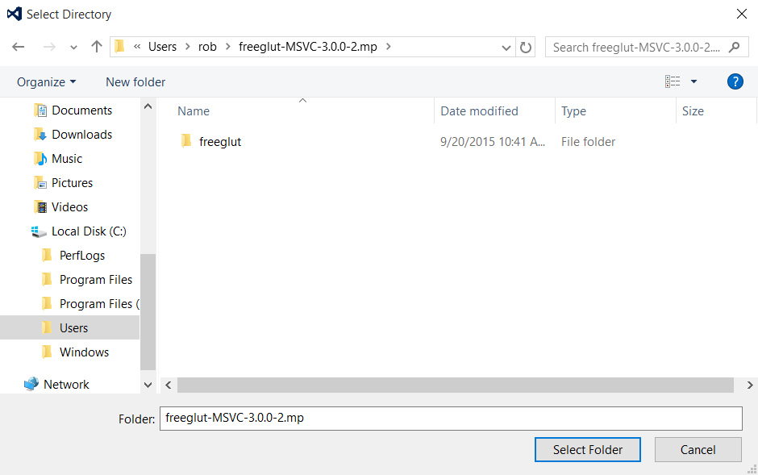

41. Select **lib** folder.

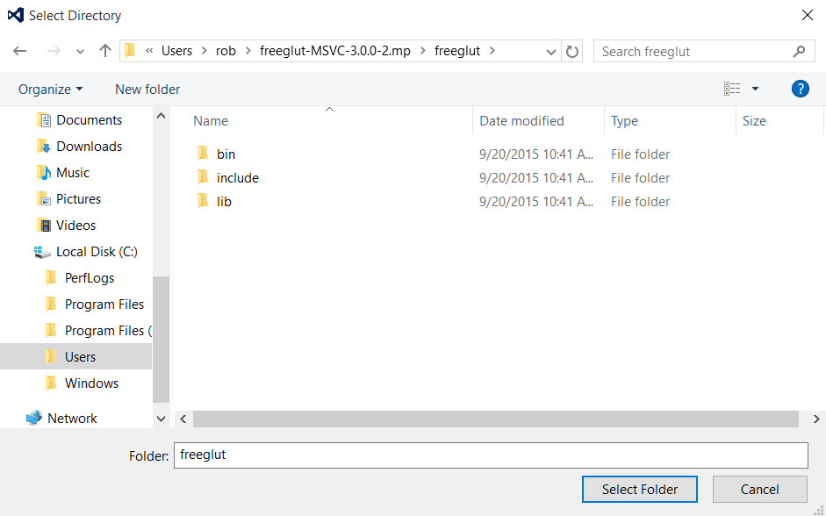

42. Press **Select Folder** button.

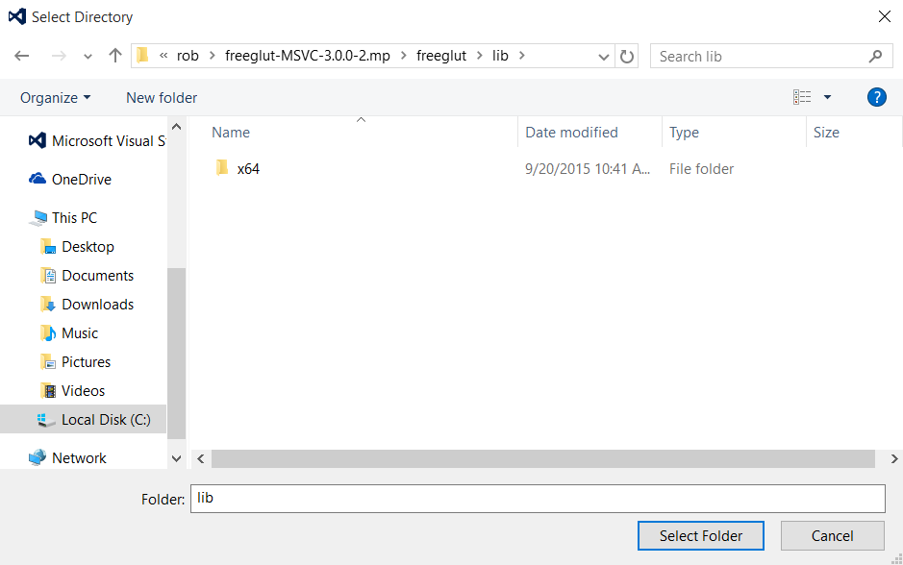

43. The file-browser window will disappear. The Library Directories window will reappear with the directory we navigated to:

C:\Users\rob\freeglut-MSVC-3.0-2.mp\freeglut\lib

Press **OK** button.

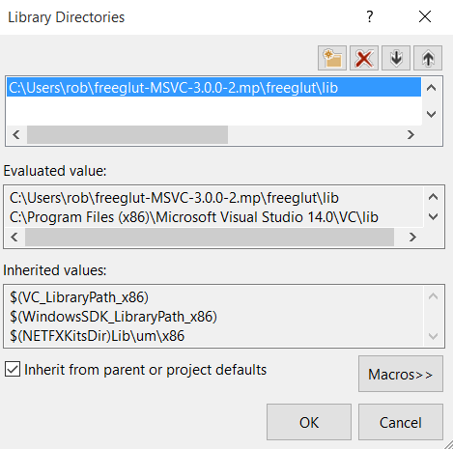

44. Notice that Library Directories now has the following path added:

C:\Users\rob\freeglut-MSVC-3.0-2.mp\freeglut\lib

Click **Apply** button.

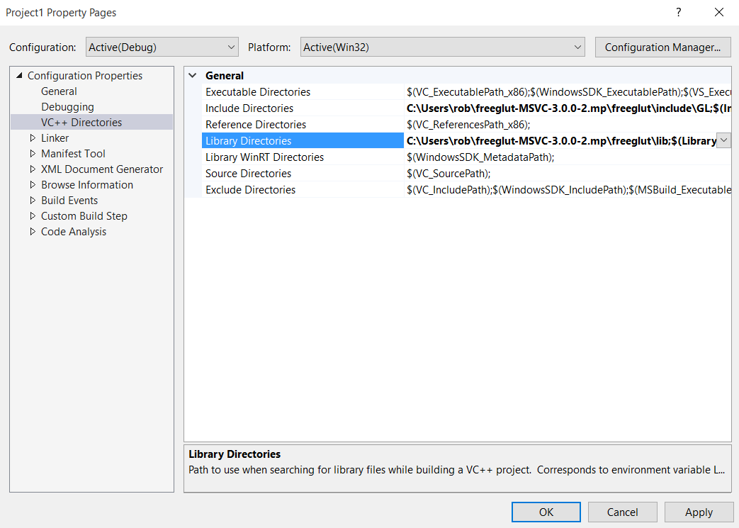

45. The next step is to configure Visual Studio Express with the freeglut dynamic link libraries (DLL). Click the triangle next to **Linker** to expand its configuration properties.



46. Now click **Input**

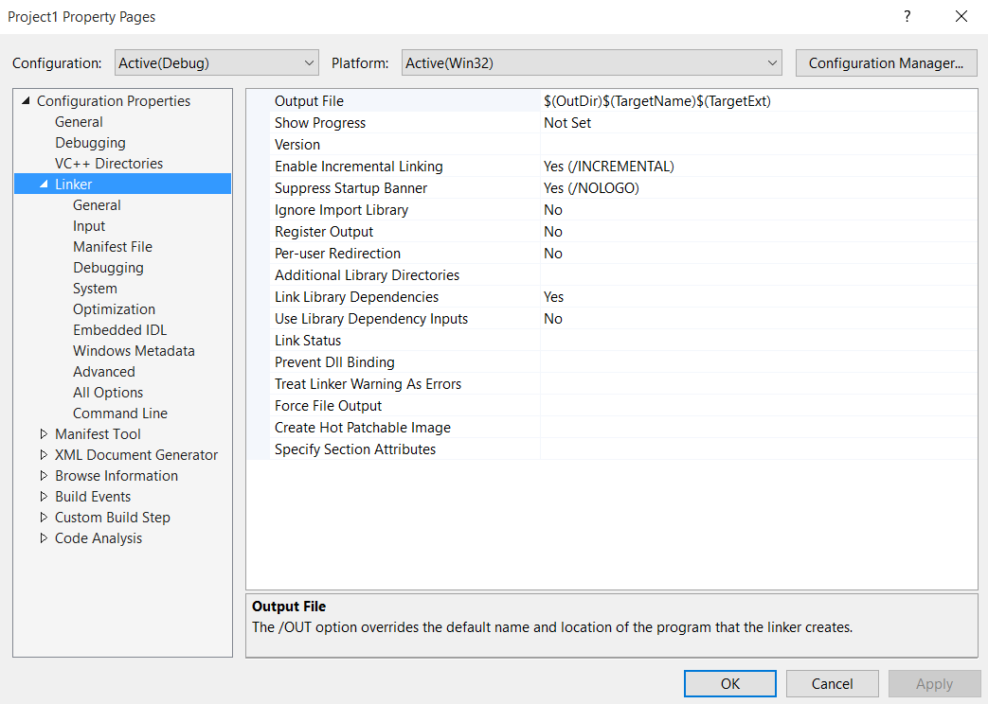

47. Click on **Additional Dependencies**

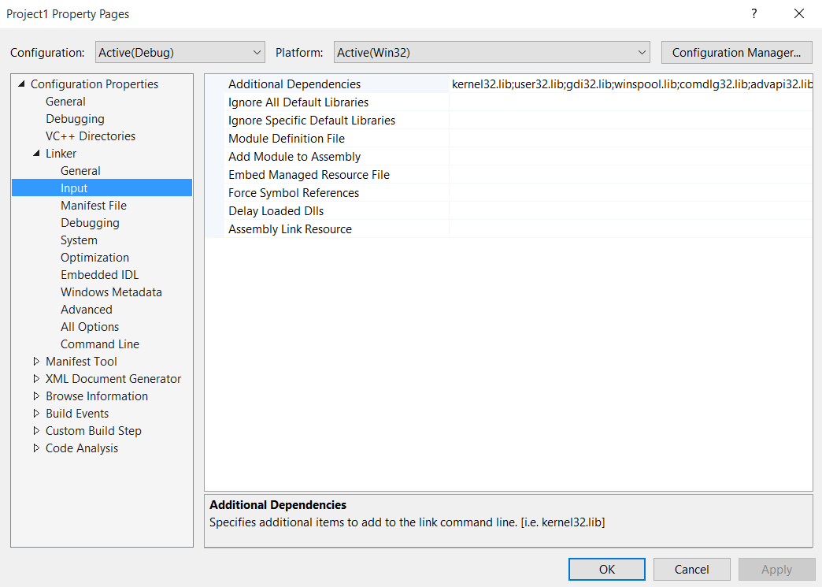

48. Click the **grey pull-down box** to expand additional dependencies.

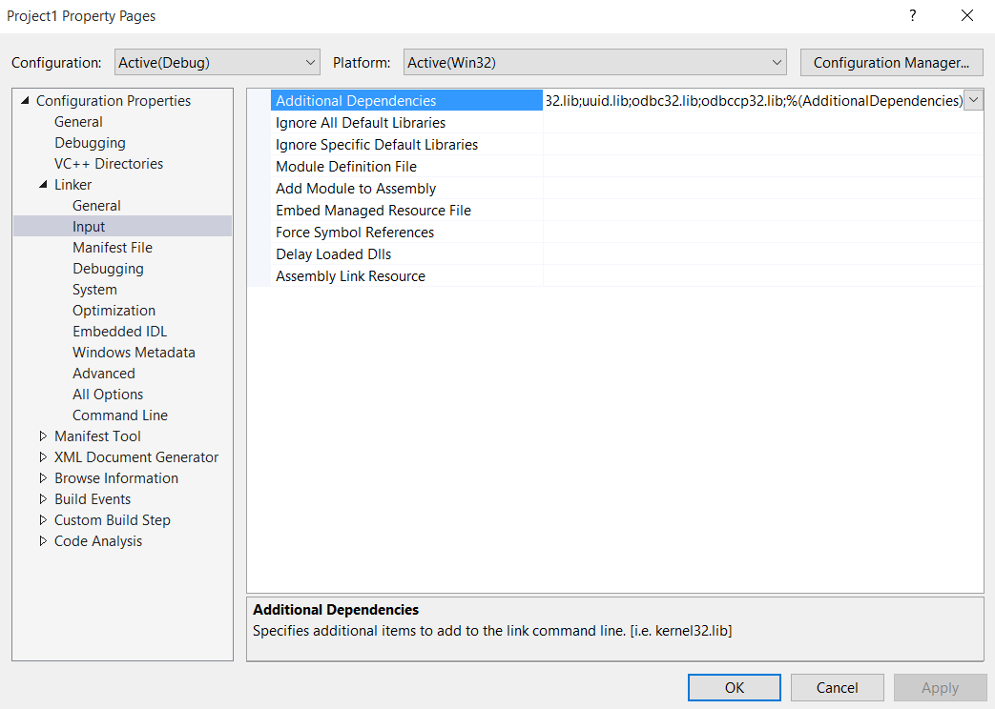

49. Click **<Edit…>**

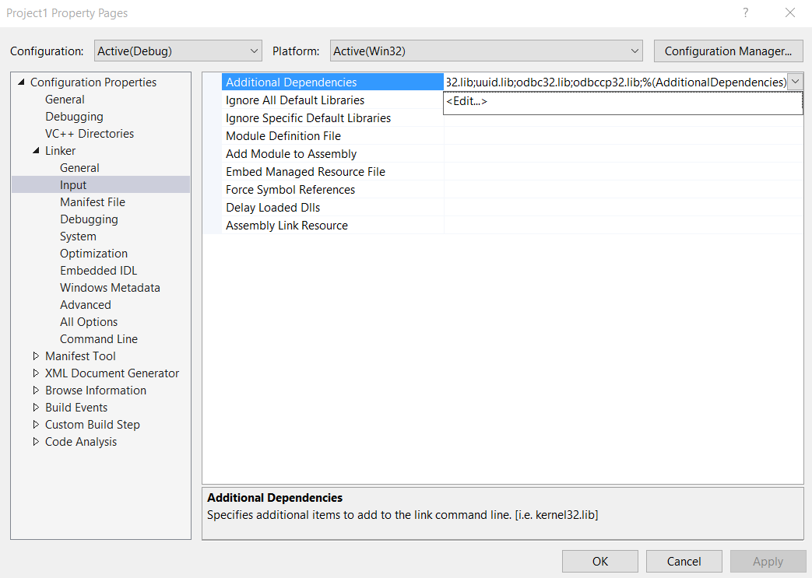

50. A new pop-up window will appear. Add the following text inside the **Additional Dependencies** text box:

**OpenGL32.lib;**

**freeglut.lib;**

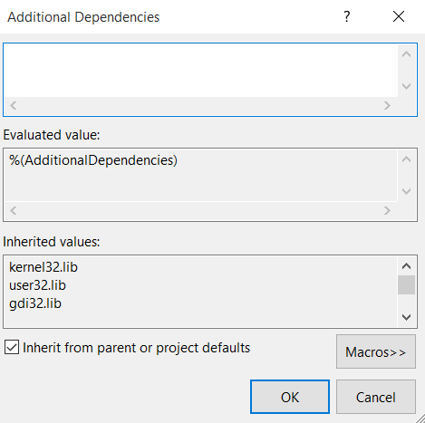

51. Click **OK** button.

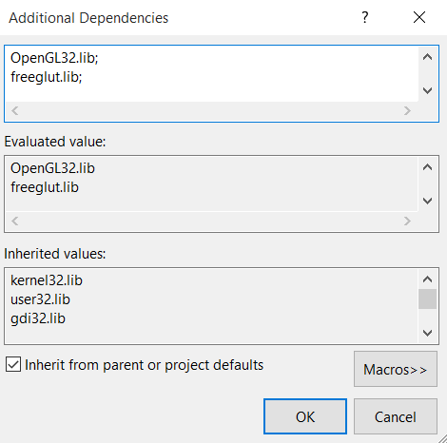

52. Note: Additional Dependencies now includes “OpenGL32.lib;freeglut.lib”. Click **Apply** button.

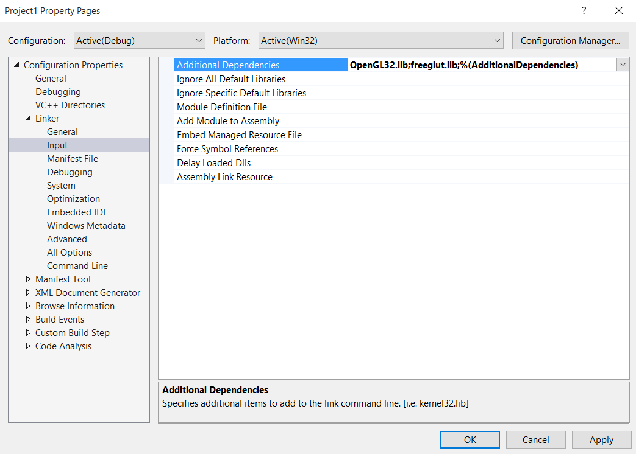

53. Click **System**



54. Click **SubSystem**

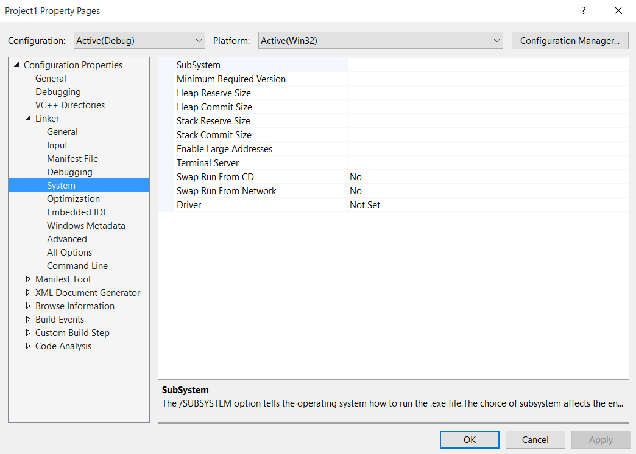

55. Click the **grey pull-down** button for SubSystem.

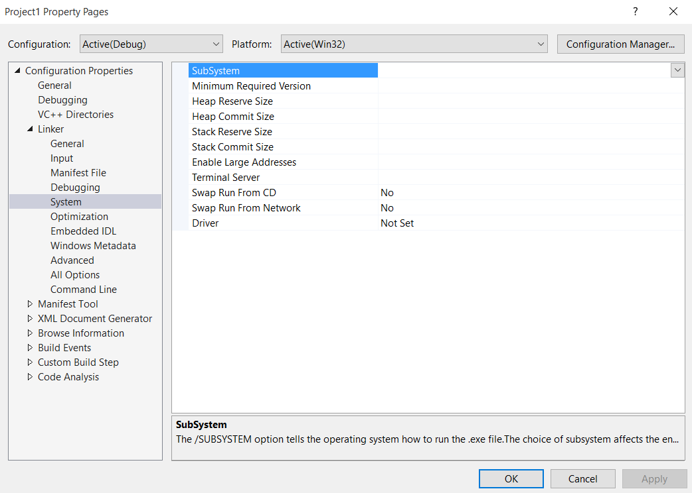

56. Select **Console** from the pull-down menu.

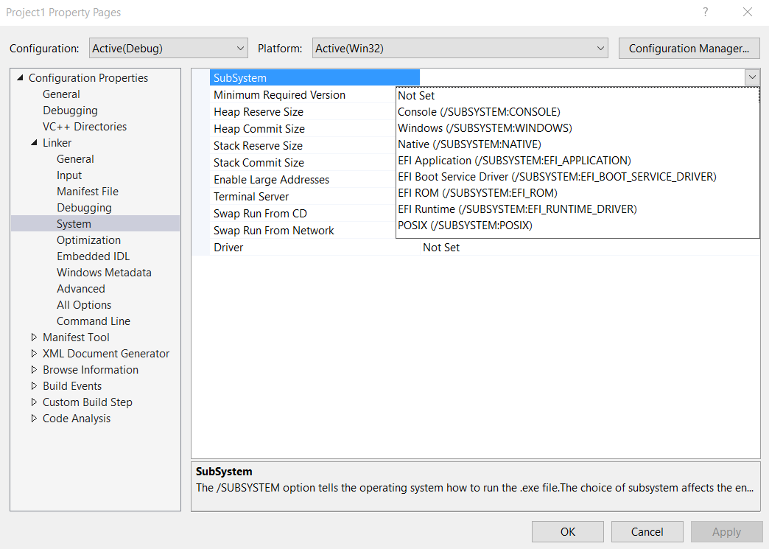

57. Notice the SubSystem has Console highlighted. Click **Apply** button to make the change permanent.

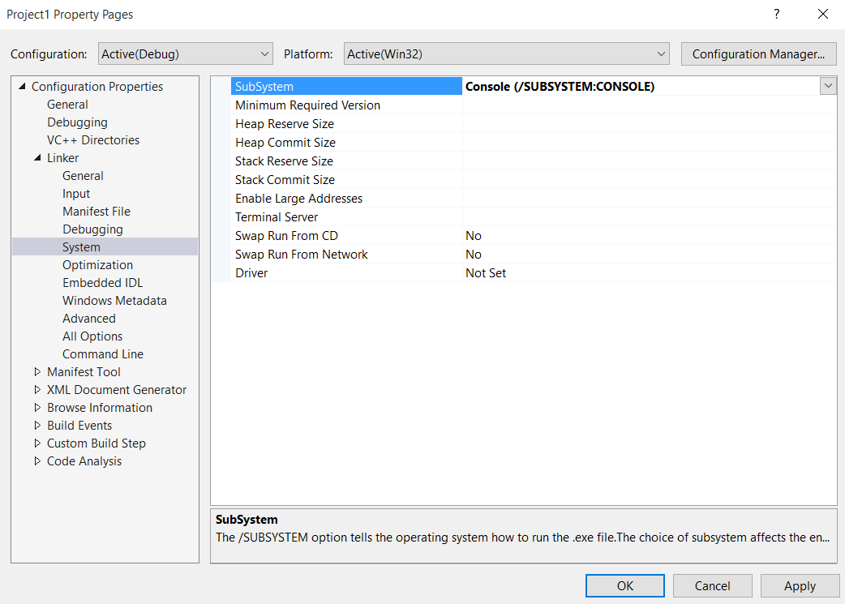

58. Now click **OK** button to exit Project1 property pages. We are all done with configuration. Next step will be compiling an example program!



59. Visual Studio Express brings us back to main development window.

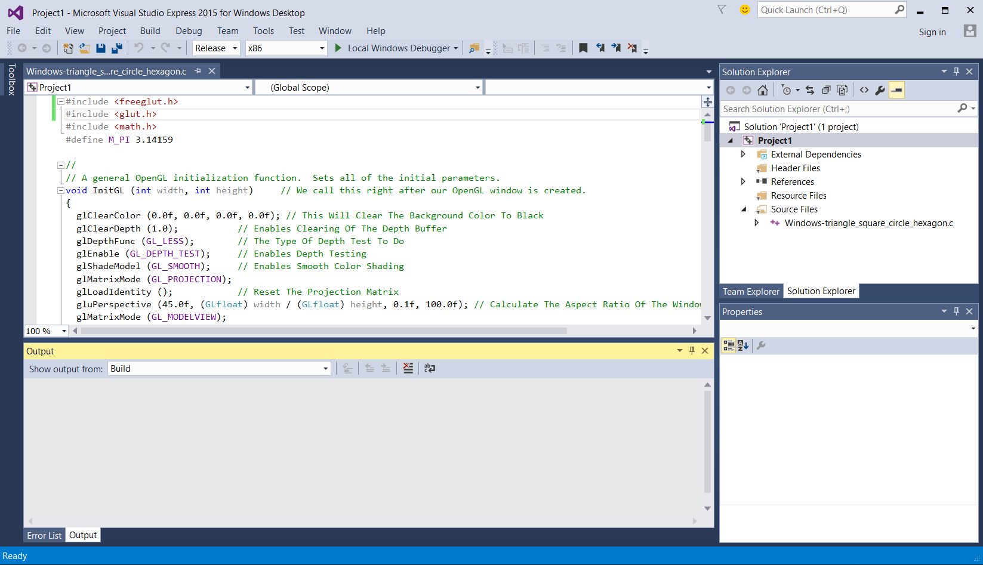

60. Before we can build our project, we must first make a copy of the 32-bit freeglut dynamic linked library (DLL) where our executable project1 resides. In this example, project1 resides at the following path:

C:\Users\rob\Documents\Visual Studio 2015\Projects\Project1

Here is a screenshot of that folder:

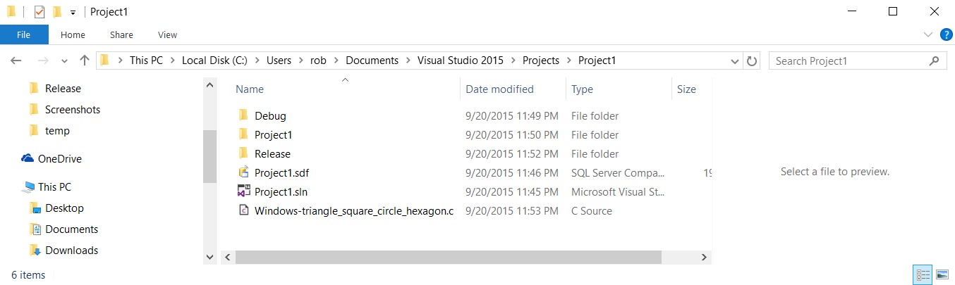

Click on the Release folder (if it exists). The full path is:

C:\Users\rob\Documents\Visual Studio 2015\Projects\Project1\Release

Here is a screenshot of the Release folder:

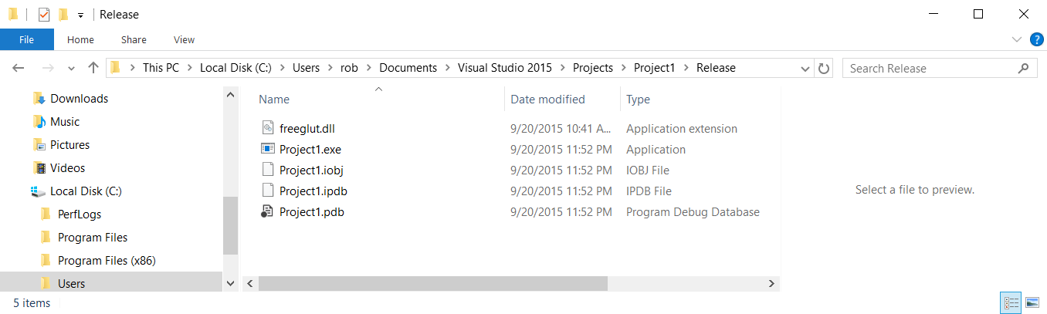

**IMPORTANT:** You must make a copy of freeglut.dll. Use the 32-bit version of this library (since we will be compiling 32-bit applications) into this directory. Do not worry if you are running a 64-bit operating system.

**COPY:** C:\Users\rob\freeglut-MSVC-3.0-2.mp\freeglut\bin\freeglut.dll

**TO:** C:\Users\rob\Documents\Visual Studio 2015\Projects\Project1\Release\

This will make a local copy of the 32-bit version of freeglut into our program’s build directory where our executable program will be.

61. We are now ready to build (compile) our project. Select **Build**

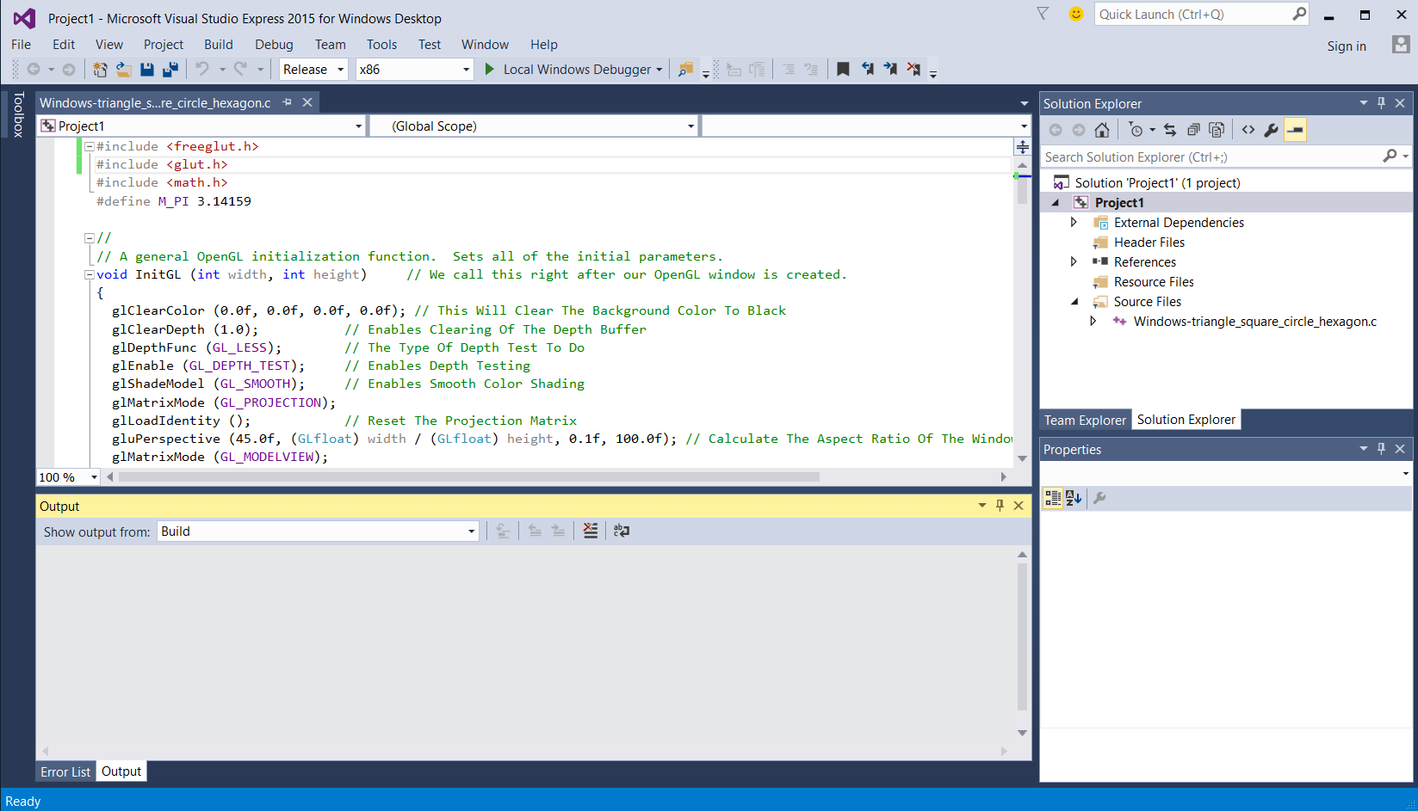

62. Select **Build Solution**

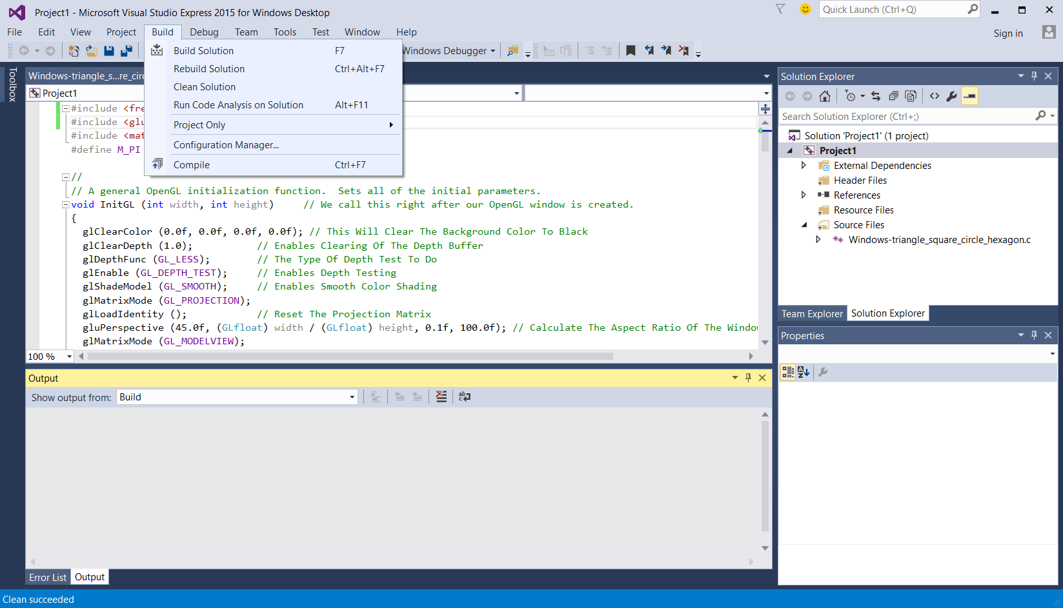

63. If your program compiled without errors, click the **green triangle run** button.

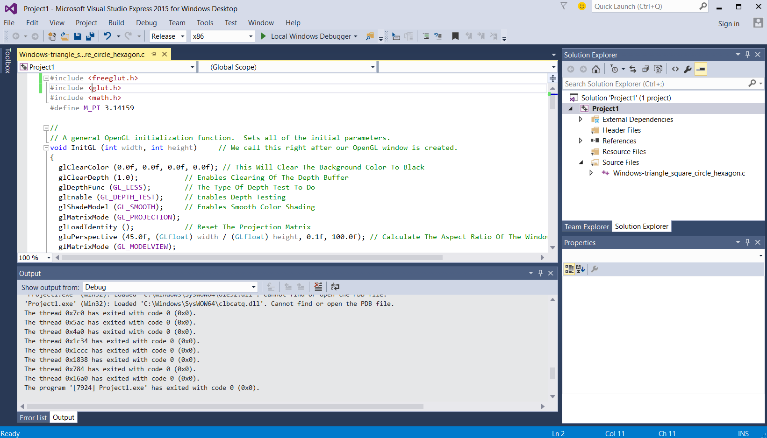

64. Here is the programming running on Windows 10.

